Hand Out for Map & Compass
Navigation Workshop
Recreation Services, University of Manitoba

Topographic Map Symbols
Road - hard surface, all season |  (multi-lane)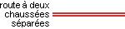
Road - loose or stabilized surface, all season
Trail or portage
Contours; index, intermediate, depression. Check the contour interval on the map for units. | 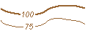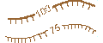
Wooded area | 
Lakes & Rivers, Streams, Intermittent  Marshes (no trees), Swamps (treed) | 
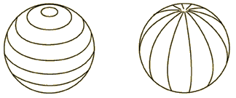
Latitude.
A point north or south of the equator, perpendicular to the lines of longitude. Latitude is measured in degrees from 0 (equator) to 90 (pole). One minute of latitude equals one nautical mile. Think of lines of latitude as a series of hoops around the earth parallel to the equator.
Longitude.
This is the distance east or west of the prime meridian measured in degrees. Lines (meridians) create a geographic grid around the world that meet at the poles are furthest apart at the equator. The lines give the impression of a pumpkin.

UTM/MGRS
UTM (Universal Transverse Mercator) grid coordinates are expressed as a distance within each zone in meters measured from the west, referred to as the "easting", and from the south, referred to as the "northing”. UTM zones are setup so there is minimal measurement error across the whole zone with the biggest difference being 0.9996 of the true scale. True scale occurs about 180km on each side of the central meridian of each zone.

Co-ordinates are read across the map (start from west), then up the map (start from south). If you are sharing this information with others you will want to quote the UTM and/or MGRS grid reference or map ID along with the datum.
(e.g. NAD 83 14U 633826 5518867, or 14U PA 338188).
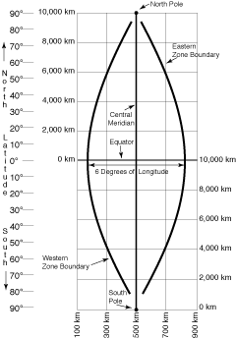
Map Scale
This is the ratio of map space to ‘real’ space. Typical scales for topographic maps in Canada are 1:50,000 (1cm=500m), 1:250,000 (1cm=2500m). There are other scales available but they are typically special purpose maps (e.g. 1:20,000 for Riding Mountain National Park). Scale is a relative measure: Larger scale maps show greater detail but less of the earth; Smaller scale maps show more of the earth but less detail.

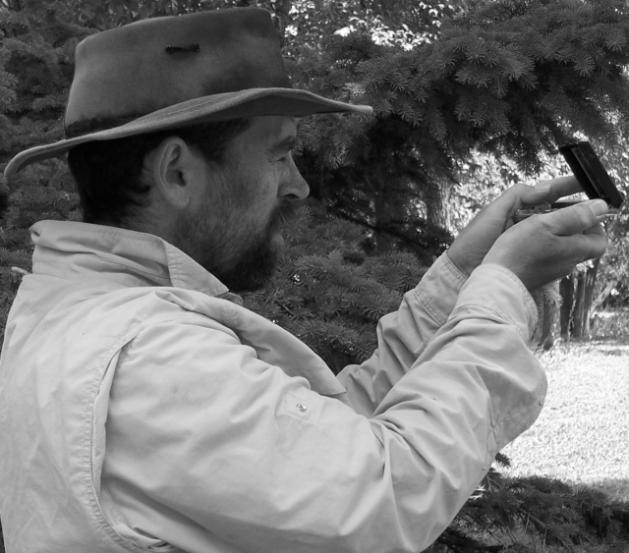
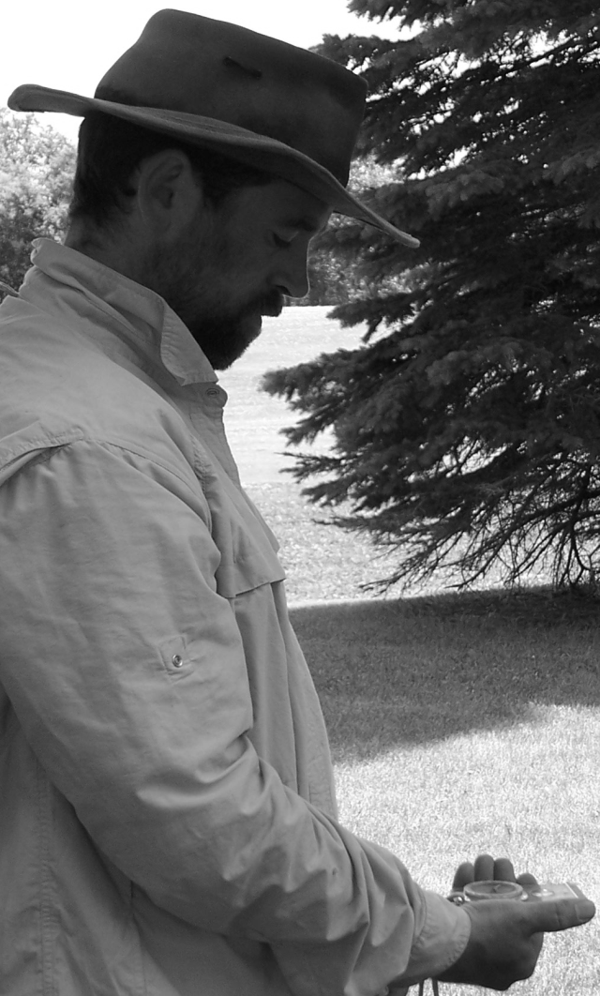
Compass (baseplate or Orienteering)
- Hold the compass level, at waist height, with the direction of travel arrow pointed in the direction you want to go. Align yourself and the compass so they are pointing (facing) the same direction. Make sure there is nothing metallic near the compass.
- Turn the rotating case until the red end of the needle is inside the orienting arrow.
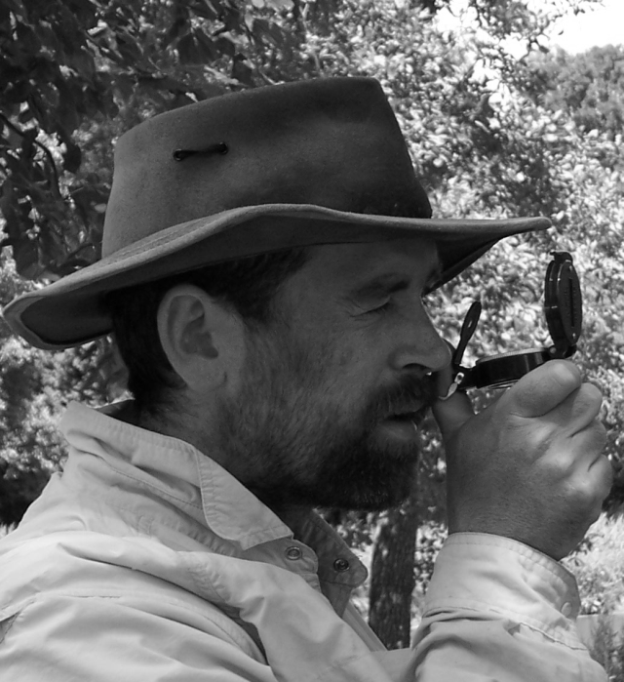
- Read the bearing from the direction of travel line at the front of the rotating case. Some compasses have the words ‘READ BEARING HERE’ stamped on the base plate.
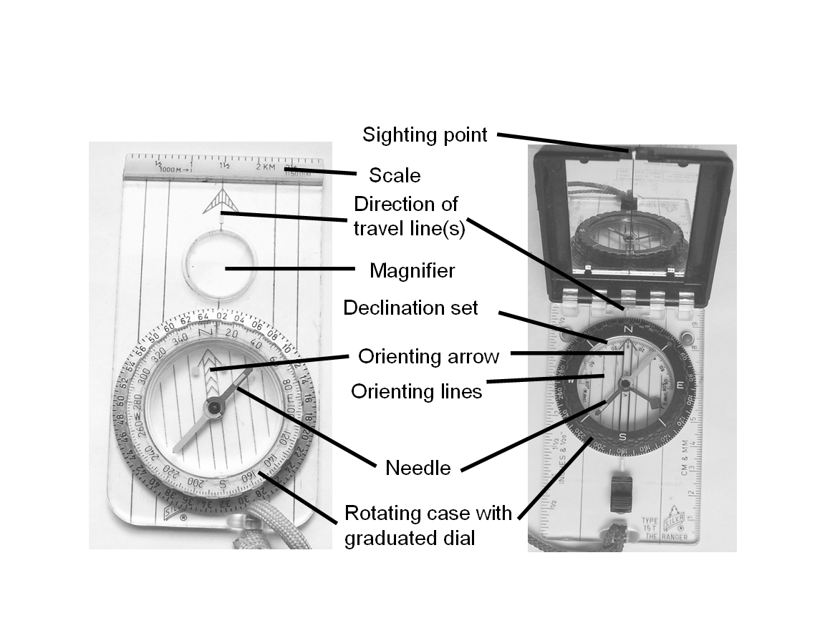

When returning along a bearing make sure that you are headed for a base line, or that you know what features bracket your destination. In most cases you will want to ‘aim off’ from your destination so when you find your base line you know which direction your destination is located.

Map and Compass
Determine the declination correction for your map and adjust for the annual change, and grid. Remember there are 60 minutes in each degree, and 60 seconds in each minute; you can’t just subtract (or add) minutes.

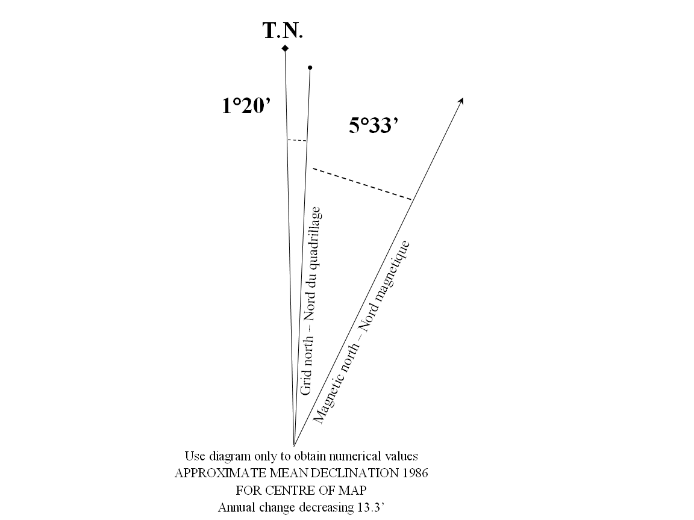
Map (grid) to Compass (magnetic)
- Line a the side of the compass between your current position and the position you want to reach. Make sure the direction of travel arrow is pointed to the position you want to reach.
- Turn the rotating case until the orienting lines are parallel to the grid lines on the map and the orienting arrow is pointed to the top (north) of the map.
- Remove the compass from the map and adjust for the declination. If the declination is east then subtract the declination correction.
Compass (magnetic) to Map (grid)
- Take a bearing from your current position to a known map location or landmark.
- Adjust for the declination. If the declination is east then add the declination correction.
- Place the front corner of the compass on the landmark and rotate the base plate until the orienting lines run parallel to the grid lines on the map. With a pencil draw a line using the side of the compass through your current point. Repeat the process with one or two more landmarks.

Easy ways to remember which way to correct for declination:
Map to compass, east is least.
Empty sea, add water (Map To Compass, Add West)
Use a compass with a declination adjustment feature (just don’t forget to re-set)
Some people pencil in a magnetic north grid on the map before leaving home.

Additional Reading:
Print Resources:
Callan, Kevin. The Happy Camper. The Boston Mills Press, © 2005
Seidman, David, Paul Cleveland. The Essential Wilderness Navigator 2nd ed., Ragged Mountain Press, © 2001.

Web Based Resources:
Topo 101 - Topographic Maps, The Basics, http://maps.nrcan.gc.ca/topo101/index_e.php. Natural Resources Canada. 2006.
How to use a compass http://www.learn-orienteering.org/old/. Kjernsmo, Kjetil.
Online Declination Calculator, http://gsc.nrcan.gc.ca/geomag/field/mdcalc_e.php. Natural Resources Canada. 2006.
Navigation Workshop, http://home.cc.umanitoba.ca/~burchil/mantario/navigation.html. Burchill, Charles A. 2006
Assiniboine Park Field Activities
Map
- Orient yourself to the map and the area that you are currently standing. You may do this using your compass or landmarks so you can comfortably read the map. Locate the Pavilion, park entrance to the English Gardens, main entrance to the park. The following grids have been provided on this map – UTM grid (blue), Lat/Long grid at 30” intervals (black), magnetic north lines (red). Most of the work today will be using grid north and magnetic north. Check the declination correction needed between grid and magnetic (just less than 3 degrees).
- Find marker 15 and estimate the UTM location of this marker. Note the location of the forest area on the map. This marker is part of the permanent Assiniboine Park orienteering course.
- Find marker 14 and estimate the UTM location of this marker. Note the location of the road, foot path, fence line and forest area on the map.

Compass
- Walking a line: From the Water Fountain identify a bearing of 28°. You should see an Oak tree in the open near the west end of the small wooded area. Close your eyes and walk the bearing for 50 paces – without looking. Someone else in the group will make sure you don’t trip or fall. Open your eyes and look straight ahead. Note the direction you are facing at the end, did you go in a straight line? What are the implications?
- Identification of a bearing and walking that line. In pairs take a bearing of 104°. Have one person walk part way along this bearing. Have the second person stay at the fountain and check the bearing then ‘leap frog’. Have the second person walk past the first and continue to the fence and have the first person check the bearing. You might be able to identify the Red Pine or Elm along this bearing and walk all the way. .

Map and Compass
- Using the flag from the pavilion (or the water fountain) and the Citizens Hall of Fame monument (you will need to crouch to see under the trees) or Orienteering point 14 triangulate your position at the elm tree along the fence. To translate compass bearings to grid bearings on the map remember to add about 3 degrees to the magnetic bearing when transferring to the map. If you can see other points you can also use these in your triangulation.
- The fence line is a known line, or baseline, along which you can travel. Locate the point along the fence line where the pavilion flag can be seen at 266° magnetic. Draw a line on the map from the pavilion that represents this line (remember to add about 3 degrees). Walk to this point you should be near an elm tree next to the fence.
- From your current location determine the direction to the water fountain on the map (using grid north). Measure the approximate distance. You can not see the fountain from this point, how would you walk?

GPS and Map
- Note the location of the water fountain on the map and create a waypoint on the GPS; are they the same? The water fountain location is estimated: 14U 627699 5525709.
- Enter the location of the monumented point at the park entrance (14U 627230 5525371). Walk to this point using the GPS directions, take note of the bearing and check your compass – does it make sense?
- Once you arrive at the point how close do you get to the ‘known’ location? Monumented points have known positions and/or elevations that have been determined, to support the spatial referencing of land-related information. This point is part of the city survey system and on a larger scale it is part of the Canadian Spatial Reference System (CSRS).

