PLNT 2530 - Plant Biotechnology
Name:
Student ID number:

Assignment 1

1. Terminal window, showing command prompt, and results of echo $birch, echo $SHELL, echo $PATH and ls -l commands.
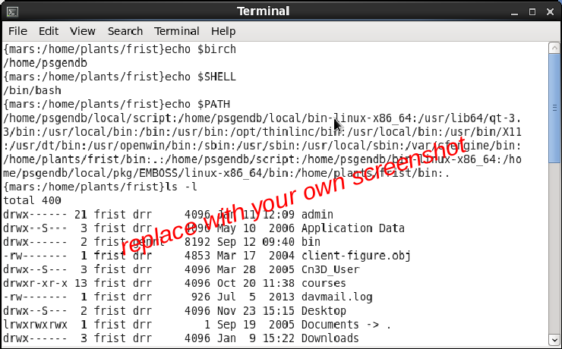

2. Screenshot of entire screen showing final setup for desktop, web browser and file manager.

