PLNT 2530 - Plant Biotechnology February 2024
Name
Student ID number

Assignment 2

1. (5 points) Search for and retrieve the pBI121 cloning vector
#QUERY: paste your search term from column A here.
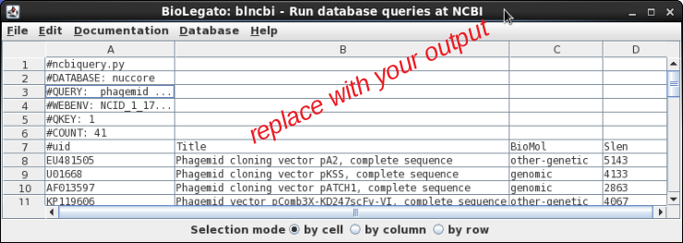
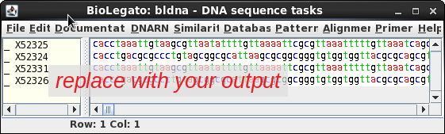

2. (10 points) Search for and retrieve the tan spot necrosis toxin gene, ToxA.
#QUERY: paste your search term from column A here.

If you need to do additional queries, add additioinal pages with the appropriate query terms and screenshots.

