PLNT2530 Plant Biotechnology

Lab - Plant Regeneration
Name (ID#): Joe Shlobotnik (01234567) shlobj@myumanitoba.ca
This assignment is worth 30 points.

1. (15 points) Weekly Observations
For each week, fill in the number of days after beginning culture of the explants. Insert images from your plates which best illustrate the differences between treatments, from week to week. Briefly describe what evidence is seen for hormone effects.
Week 1 - _0_ days in culture
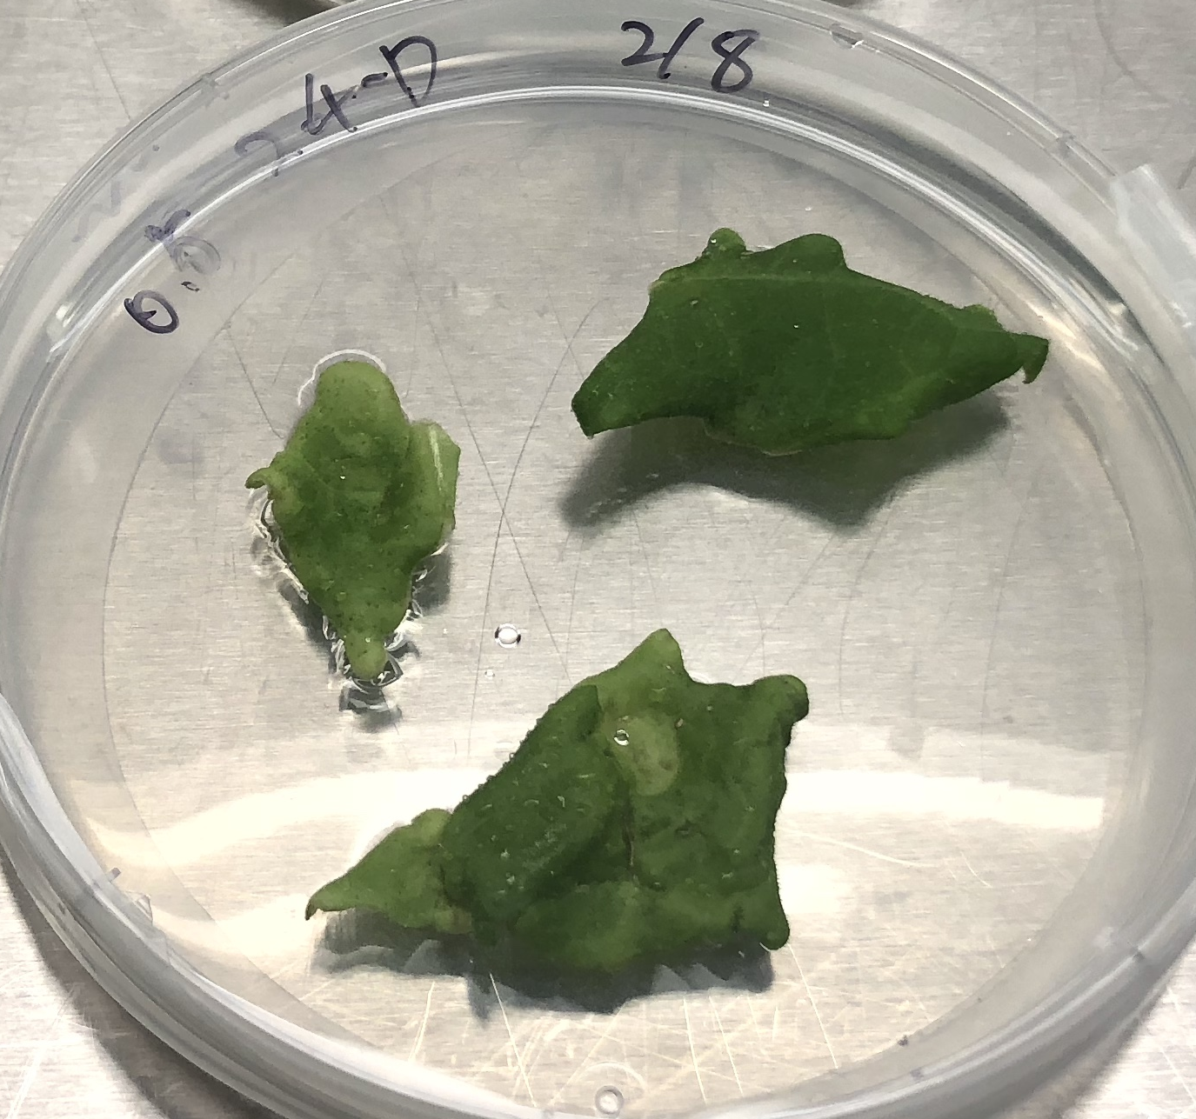  A 0.5 mg/L 2,4-D  rooting | 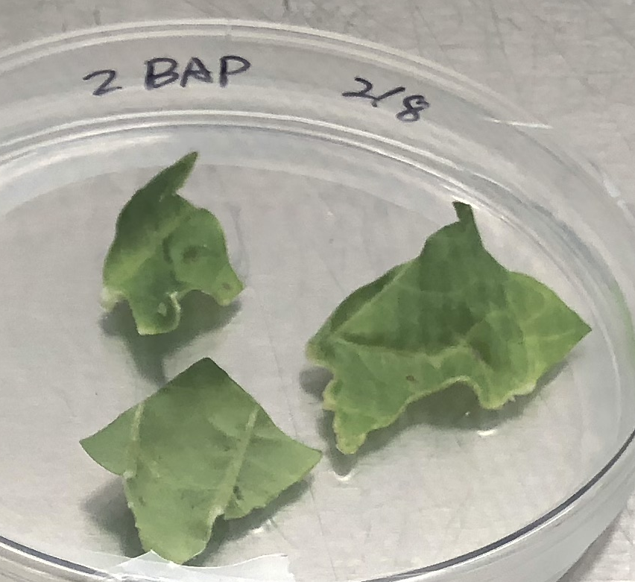  B 2.0 mg/L BAP  shooting | 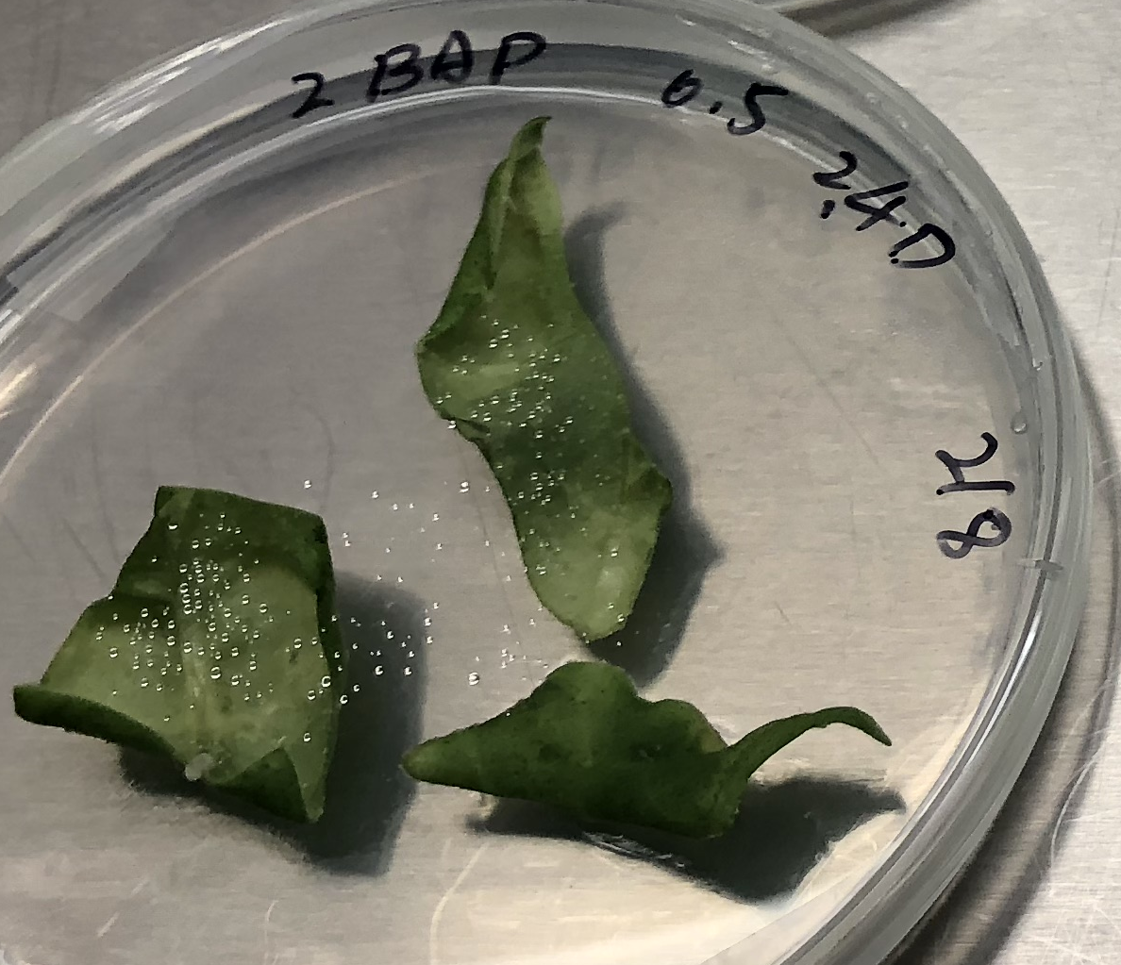  C 2.0 mg/L BAP, 0.5 mg/L 2,4-D  shooting
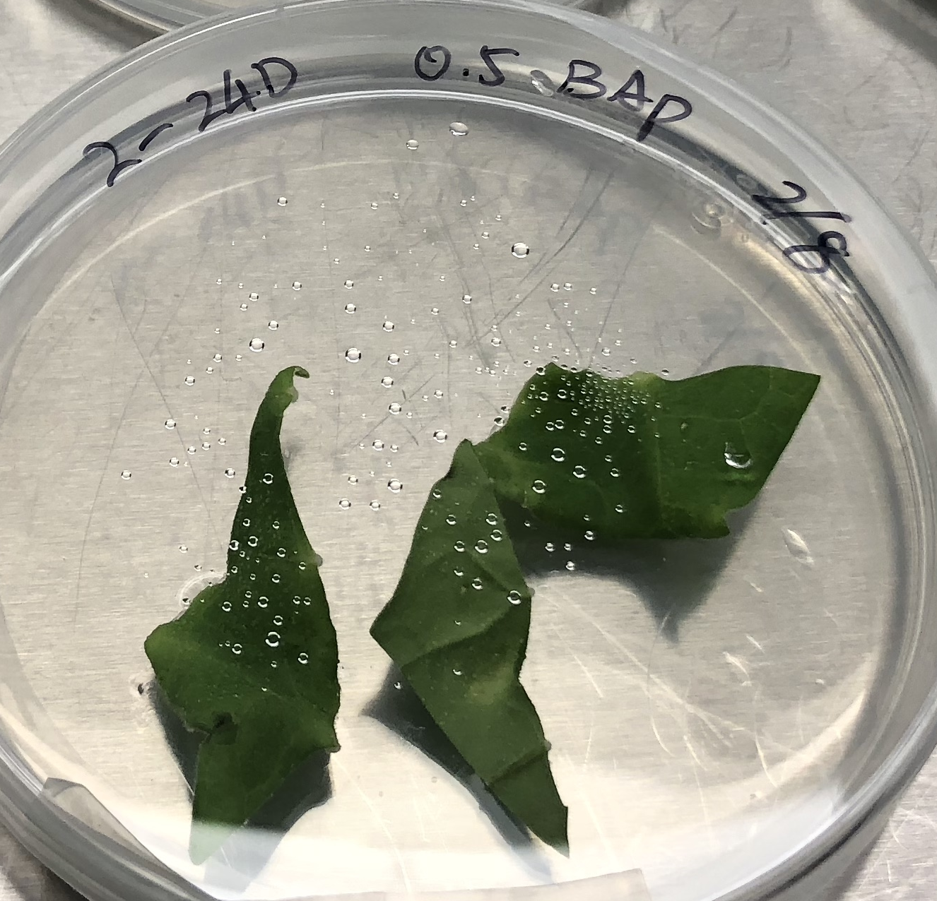  D 2.0 mg/L 2,4-D, 0.5 mg/L BAP  rooting | 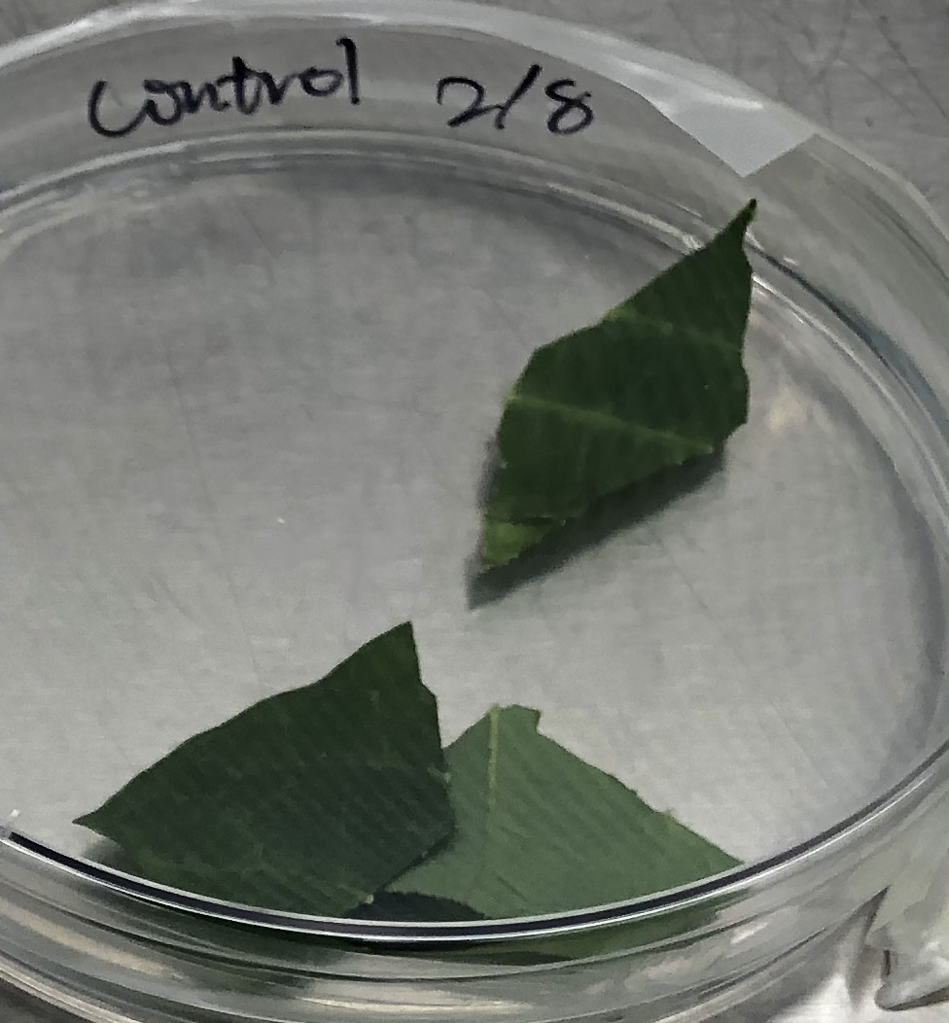  E - Control (no hormones)

Week 2 - __ days in culture

Week 3 - __ days in culture

Week 4 - __ days in culture

Week 5 - __ days in culture

Week 6 - __ days in culture

Week 7 - __ days in culture

Week 8 - __ days in culture

