PLNT3140 INTRODUCTORY CYTOGENETICS October 2022

Meiosis Lab Assignment
Name (ID#): Joe Shlobotnik (01234567) shlobj@myumanitoba.ca
This assignment is worth 30% of the lab grade.
Due date: November 30, 2022

1. Diplotene or Diakinesis - Explain how you know this is Diplotene or Diakinesis
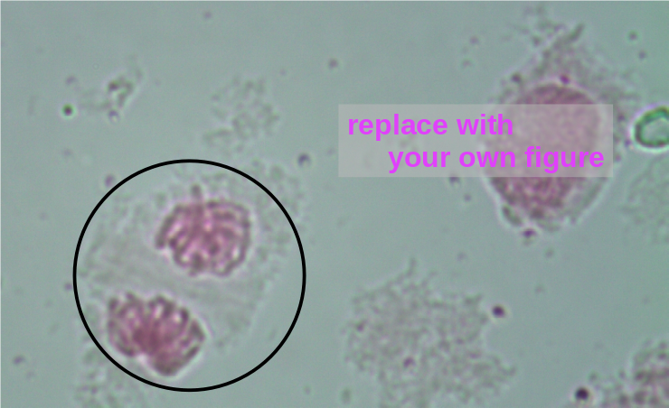

2. Metaphase I - Explain how you know this is Metaphase I

3. Anaphase I - - Explain how you know this is Anaphase I

4. Metaphase II or Anaphhase II - - Explain how you know this is Metaphase II or Anaphase II

