Lack of Healthy Food In the Midst of Plenty: The Food Security Crisis in Northern Manitoba.

Summary
Is healthy food on the table in Northern Manitoba? No. Many households cannot afford to put healthy food on the table. These households run out of food and money with children and adults going without food and depending on low quality food. According to our 2009 household food survey in 14 communities and 534 households the rates of food insecurity are 75% amongst northern households. This is eight times the level across Canada. Clearly a food crisis is occurring in Northern Manitoba that needs immediate attention of the public and policy-makers.

Introduction
Many families in Northern Manitoba lack access to affordable nutritious foods, particularly perishables such as fruits and vegetables. Problems associated with food access in remote communities include limited food selections, high food prices, and poor quality of fresh produce. These in turn are linked to high transport costs and difficult logistics, [e.g. air freight charges, and uncertainty of travel on winter roads], high poverty rates in northern communities, and a continuing decline in the use of country foods (Northern Food Prices Steering Committee, 2003). From descriptive studies like the Northern Food Prices Report (2003) food insecurity rates were expected to be higher in the north – but how much higher was unknown as Health Canada did not research food security in First Nation reserves in studies that analyze every other community. This household food security survey carried out as part of this evaluation provides the first quantified data on food insecurity in northern Manitoba’s First Nation Communities.

Food insecurity is a consequence of inadequate access (or threats to adequate) healthy food in terms of quantity or quality: “Food security exists when all people, at all times, have physical and economic access to sufficient, safe and nutritious food that meets their dietary needs and food preferences for an active and healthy life”(World Food Summit, 1996, p. 1). Having access to nutritious affordable food is one of the conditions required to make healthy choices possible but access to fresh fruit and vegetables can be compromised by high cost, lack of income and unavailability due to remote location.

Methods
A standardized measurement tool was used, applying the version that was adapted for Canada (Health Canada, 2007, pp. 45-49). A survey of 534 households in northern Manitoba was undertaken in the summer of 2009 in 14 communities. In most of these 14 communities approximately 50 households were surveyed, with the population limiting the number to less in a few communities. In very small communities a census rather than a sample was conducted. For example, every household in Granville Lake, Ilford, Thicket Portage and War Lake was surveyed. However, please note that for Wasagamack the sample is small unrelated to the population size and caution should be taken in interpreting the results for this community. The survey was analyzed using excel and SPSS as outlined by Health Canada for: 1) children in households for the eight child-referenced items; and 2) for adults in households for each of the ten adult-referenced items. The more times an affirmative response was made the greater the degree of food insecurity. In households considered moderately food insecure there are compromises in quality and/or quantity of food consumed. Households that are considered severely food insecure have reduced food intake and disrupted food patterns.

Findings
Across northern Manitoba, food insecurity affected the majority of households. Three-quarters of all households experienced food insecurity (n=534, 42% moderate and 33% severe equals 75% total) (Figure 1.1) and two-thirds of households with children experienced food insecurity (n=463, 33% moderate and 24% severe equals 57% total) (Figure 1.2). The 95% confidence intervals show these percentages may vary by 2%. All households had greater moderate and severe food insecurity than households with children and it appears that households with moderate food insecurity are better able to privilege children’s eating needs than households with severe food insecurity.

Figure 1.1. Household food security in Northern Manitoba.*
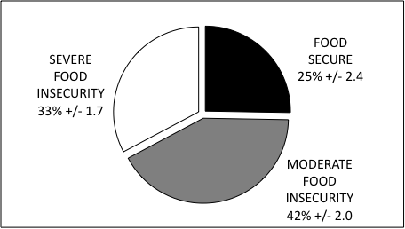
*Percent (weighted by sample size) of households in Northern Manitoba that experienced food security (black), moderate food insecurity (grey) and severe food insecurity (white) (95% confidence). Food secure means both adult- and child-related questions indicated food security. Moderate food insecurity means either or both adult- and child-related questions indicated moderate food insecurity and neither indicated severe food insecurity. Severe food insecurity means either or both adult- and child-related questions indicated severe food insecurity.
Figure 1.2. Food insecurity levels for children within households.*
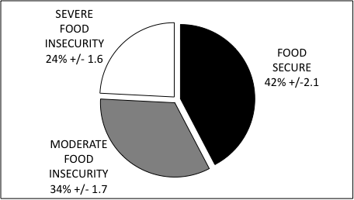
*Percent (weighted by sample size) of households with children across northern Manitoba that experienced food security (black), moderate food insecurity (grey) and severe food insecurity (white) (95% confidence).
For all households in each community the overall rate of food insecurity (moderate and severe) ranged from 47% in Nelson House to 100% in South Indian Lake (Figure 1.3). Communities with the greatest food insecurity were South Indian Lake and fly-in communities that include: Brochet, Garden Hill, Granville Lake, Red Sucker Lake and St. Theresa Point. Moderate food insecurity rates were lowest in Granville Lake (13%) and highest in Thicket Portage (85%) and severe food security rates were lowest in Ilford and Thicket Portage (0 to 5%) and highest in Granville Lake (75%). There were a greater proportion of households with severe food insecurity than moderate food insecurity in six communities: Brochet, Garden Hill, Granville Lake, Red Sucker Lake, South Indian Lake and St. Theresa Point.
For households with children the total rate of food insecurity (moderate and severe) ranged from 10% in Ilford to 88% in Granville Lake (Figure 1.4). Moderate food insecurity rates were lowest in Ilford (10%) and highest in Thicket Portage (80%) and severe food insecurity rates were lowest in Ilford and Thicket Portage (0%) and highest in South Indian Lake (53%). There were a greater proportion of households with severe food insecurity compared to moderate food insecurity in the four out of 14 communities: Brochet, Garden Hill, Red Sucker Lake and South Indian Lake. Children were more protected from food insecurity than adults.
Figure 1.3. Percent food insecurity in all households compared by community in northern Manitoba.*
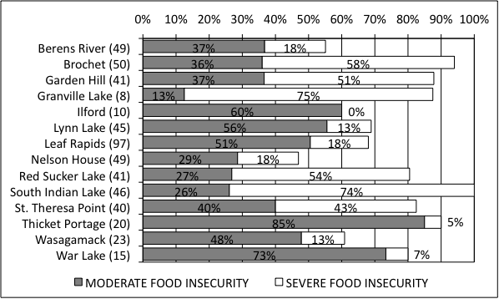
*Numbers in brackets represent sample size, the number of households that were interviewed in each community.
Figure 1.4. Percent food insecurity of children in households compared by communities.* 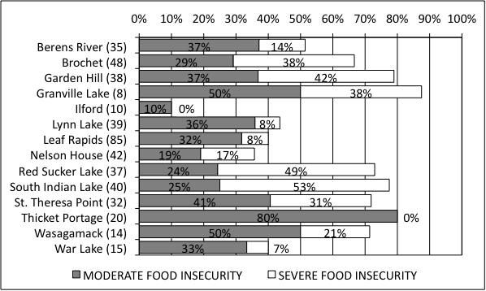
*Numbers in brackets represent sample size, the number of households that were interviewed in each community.
Communities that were remote, those without road access, had higher percentages of overall and severe food insecurity than those with road access for all households (Figure 1.5) and the children in these households (Figure 1.6), although moderate food insecurity was similar between remote and non-remote communities. Children in these households, the percentage of moderate food insecurity was also greater in communities that lacked road access compared with those with road access. Communities with lack of road access elevated the rate of overall food insecurity by 10% in all households and 20% in households with children.
Figure 1.5. Percent food insecurity of Northern Manitoba households 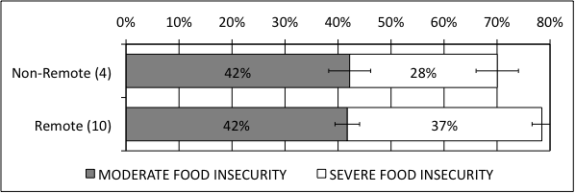
*(weighted by sample size) in all households compared by remoteness. Remote communities had no road access. The number of communities in each grouping is indicated in brackets. 95% confidence intervals provided.
Figure 1.6. Percent food insecurity comparing remote versus non-remote for Children in Households
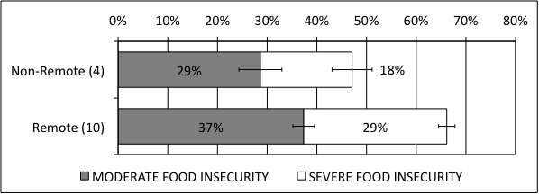
*(weighted by sample size) in households with children compared by remoteness. Remote communities had no road access. The number of communities in each grouping is indicated in brackets. 95% confidence intervals are indicated.
Remote Communities | Non-Remote Communities
Berens River, Brochet, Garden Hill, Granville Lake, Ilford, Red Sucker Lake, St. Theresa Point, Thicket Portage, Wasagamack, War Lake | Leaf Rapids, Lynn Lake, Nelson House, South Indian Lake
Conclusion
No. Healthy food is not on the table in Northern Manitoba. The great majority of people (75%) in Northern Manitoba cannot afford to eat healthy due to high prices. To put these findings in perspective, less than one-tenth of non-reserve Canadian households (6% moderate and 3% severe=9.2%) (Health Canada, 2007 p. 16) experienced food insecurity, compared with three-quarters of the households in Northern Manitoba – an eight-fold difference. These households have much higher rates of food insecurity, particularly severe food insecurity, than other populations including off-reserve Aboriginals across Canada: across the nation one-third of households of off-reserve Aboriginals experienced food insecurity (19% moderate and 14% severe=33%), as measured by Health Canada (2004). Communities without road access have greater levels of food insecurity than those with road access. These rates show a food security crisis in Manitoba’s Northern communities (First Nation and Northern Affairs communities) that needs immediate attention and dedicated resources. The great majority of households had either reduced food intake and disrupted food patterns or reduced quality or quantity of food. As well, as long-term sustainable solutions being needed, immediate action should be taken, particularly in remote communities, to prevent food insecurity.

