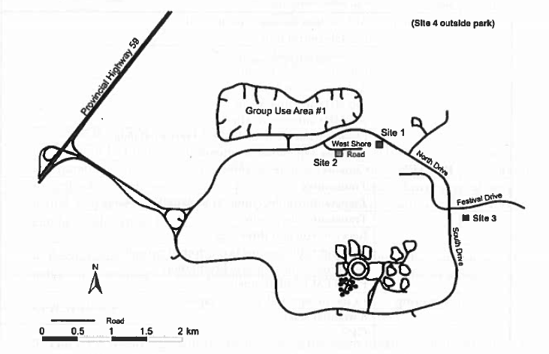

Figure 1: Overlook map area

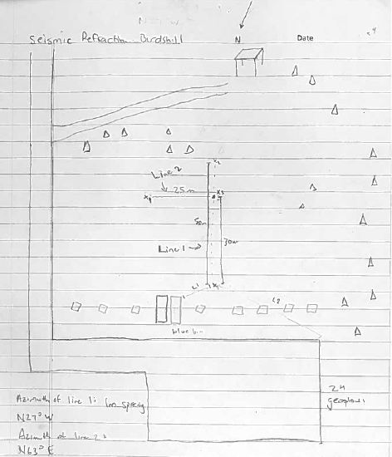

Figure 2: Seismic refraction survey map