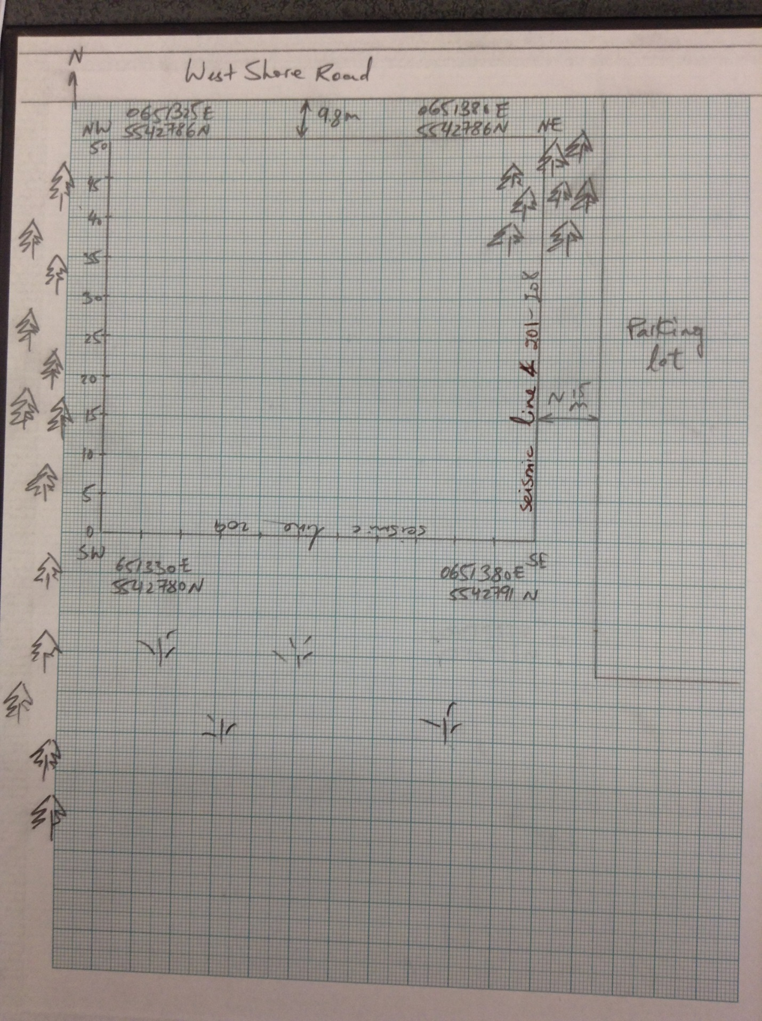

Date of Collection: April 28, 2015

Place of Collection: Birds Hill Park Site 2

Collected by Group 2

Archived by Group 2

Group Members: Yana Tyomkin , Qaisar Naseem, Shehryar Gill, Steve Kachappilly, Jason Cornick

**EM-31**

Line: Grid running south to north, 0m-50m, with a spacing of 5 metres.

Vertical and horizontal profiles were taken on all points within the 50m * 50m grid, and point (0,0) is in the SW corner at (651330E, 5542780N) coordinates. With the East-West lines represented as X-values and South-North lines as Y-values. The survey was started at (0,0); in the South-West corner.