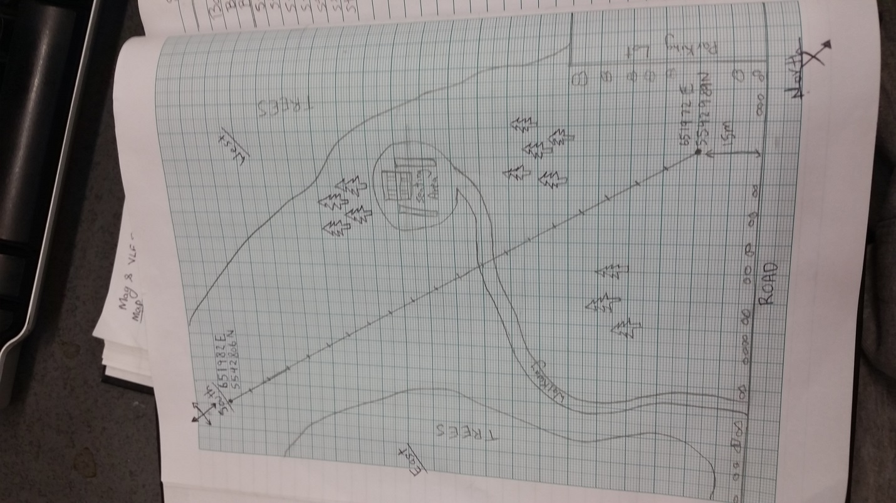

Group 2 (Qaisar, Yana, Jason, Steve, Shehryar) collected the gravity data and the elevation data on Thursday April 30th 2015 by using gravity-meter in Birds Hill Park site 3. The gravity profile was 200 m long and due south. Attached is a picture of the map.