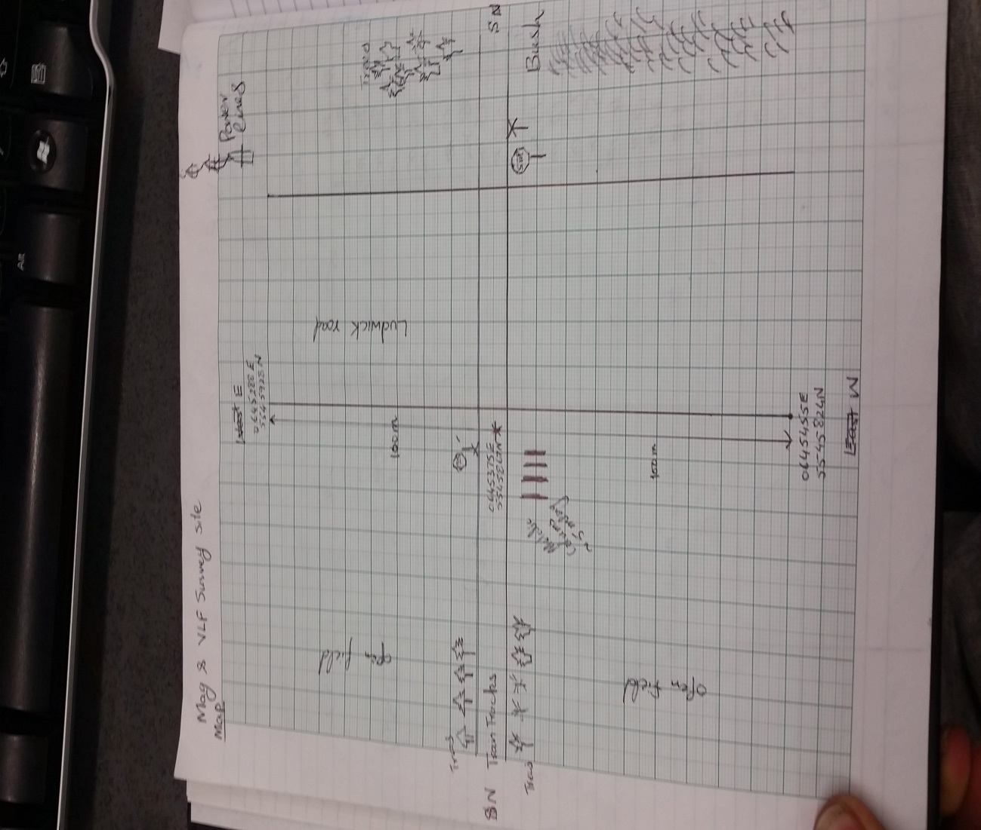

Group 2 (Qaisar, Yana, Jason, Steve, Shehryar) collected the magnetic, VLF, and magnetic gradient data on Thursday April 30th 2015 by magnetometer and VLF at Ludwick Road. The profile was 200 m long and due west. Attached is a picture of the map.