Date of Collection: April 28, 2015

Place of Collection: Birds Hill site 2

Collected by Group 2

Archived by Group 2

Survey Mode: Refraction

Group Members: Yana Tyomkin , Qaisar Naseem, Shehryar Gill, Steve Kachappilly, Jason Cornick

Line Grid running south to north from 0-50 meters, and grid running east to west from 0-50 meters. With South-east corner being (50,0), North-east corner being(50,50), North-west corner being (0,50), and South-west corner being (0,0). There was also a point during the survey when we passed a point that had the flags lying beside it (over 30 of them), and we got a horizontal sensitivity of 14, and after redoing that point, we got a horizontal sensitivity of -1. This was likely due to the metal sticks that the flags were made out of. This likely affected all our readings by a small amount, because every point had a flag on it.

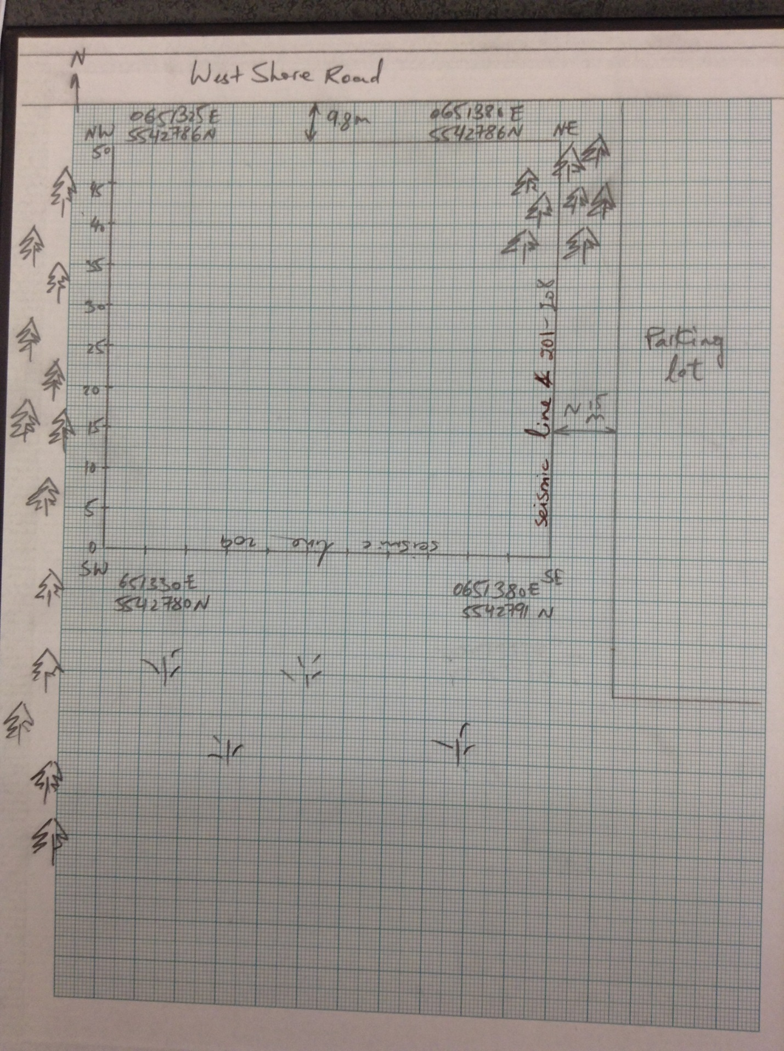

**Hammer Seismic Survey**

File 201.dat (same as 202.dat): Shot Orientation (50, 0) to (50,24)

Geophone Spacing: 1 meter

Shot Location: (50, 0)

Number of Geophones: 24

File 203.dat (same as 204.dat): Shot Orientation (50, 0) to (50, 24)

Geophone Spacing: 1 meter

Shot Location: (50, 25)

Number of Geophones: 24

File 205.dat (same as 206.dat): Shot Orientation (50, 0) to (50, 48)

Geophone Spacing: 2 meters

Shot Location: (50, 0)

Number of Geophones: 24

File 207.dat (same as 208.dat): Shot Orientation (50, 0) to (50, 24)

Geophone Spacing: 2 meters

Shot Location: (50, 48)

Number of Geophones: 24

File 209.dat (same as 210.dat): Shot Orientation (50, 0) to (24, 0)

Geophone Spacing: 1 meter

Shot Location: (50, 0)

Number of Geophones: 24

File 211.dat : Shot Orientation (50, 0) to (24, 0)

Geophone Spacing: 1 meter

Shot Location: (25, 0)

Number of Geophones: 24

File 212.dat (same as 213 & 214.dat): Shot Orientation (50, 0) to (0, 0)

Geophone Spacing: 2 meters

Shot Location: (0, 0)

Number of Geophones: 24

File 215.dat (same as 216.dat): Shot Orientation (50, 0) to (0, 0)

Geophone Spacing: 2 meters

Shot Location: (0, 0)

Number of Geophones: 24