Read me File DC Resistivity

The file BHS3-G3 is the result of the Dipole- Dipole survey which was carried out in bird hill at a point with UTM co-ordinate of 14 U UTM 06532205541985 with accuracy of 5.4 and ends at 06532985541906 with an accuracy of 5.2 which was measured with the GPS (Figure 1). A small cable was used to connect the 120 meter long cable to the electrodes which had 5 m spacing. Electric software from a laptop is used to create a sequence which then read into the syscal switch equipment and reading was taking by the equipment and transferred back to the lap by prosys software. The equipment records the kind of survey (column1), the spacing (column 2 to 5), the apparent resistivity (column 6), voltage (column10) and current (column 11).

The file Wenner data is the result of the Wenner Array Survey which was also carried out in bird hill with the GPS location of 14 U UTM 0653316 5541882 m North with and accuracy of 5.2 and the end point was 14 U UTM 0653206 5541991 m with and accuracy of 15.8 (Figure 2). The profile line is 150 m and the spacing ranges from 0.5m to 50 m. The data has been recorded in an excel file called “Wenner data”, which consists of Reader, Spacing (m), Data Collector name, Voltage (V), Current “I” (Amp), Apparent Resistivity (observed), Apparent Resistivity (Calculated) and comments columns. Tony and Sim read the result and Gafaar and Neil collected data. Three additional columns were added from calculations as follows: log(ρa) and log (a) where (a) is the spacing.

The PDF file BHS3-G3 is the resistivity cross-section map of the subsurface with a 150 Quadrupole.

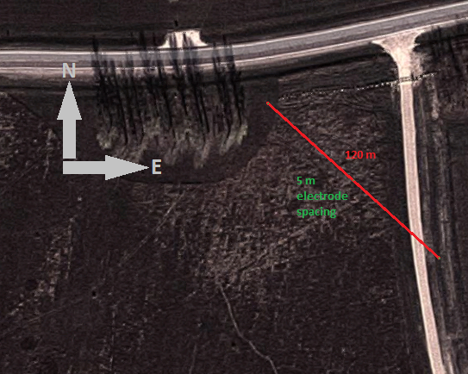

Figure 1: Dipole Dipole site3 map and Layout.

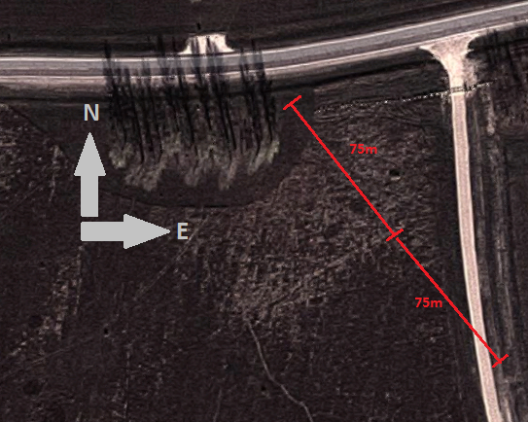

Figure 2: Wenner Profiles Site 3 Map and Layout.