# Gravity and Elevation Survey

Elevation Survey: We obtained our coordinates using **GPS** along the 200 meter line going from north to south: starting point 14U 0651972 UTM 5542989 and ending point 14U0651964 UTM 5542779 (Figure 1). We then flagged 20 meter spacing’s between zero and 200. The elevation survey was then carried out, in the middle of every 20 meter spacing from zero to 200. We used the survey measurement placed in the middle of a 20 meter spacing start from zero, as 0 represented the offset and starting point of the survey. Then Neil placed the measurement stick standing vertically at zero **offset**, while Ikemba took readings off the measurement stick using the balanced survey measurement equipment. The values taken while the survey measurement was pointing towards the starting point were the **back shot**, while for the **forward shot** values we had the tri-stand survey equipment pointing south towards the end point. This same step was used to take multiple forward and backward shot values between the spacing’s of 0-20, 20-40,40-60, 60-80, 80-100, 100-120, 120-140, 140-160, 160-180, 180-200 meters. Then we calculated a delta Z value in order to calculate the elevation, and for the elevation values the starting points of the survey was zero elevation, and we added the previous elevation value to the next 20 meter spacing to calculate an **elevation** value.

Gravity Survey: we used the exact same coordinates as listed above for elevation survey with just one addition of a base station close to the starting point with the coordinates: 14U 0651966 UTM 5542986 with an accuracy of 6.0. For the gravity survey we started by taking 3 measurements values of the **gravitation field** at the base station using the Worden Gravity Meter instrument. We also recorded the time each gravitation field value was taken although the survey and the GPS location of that position. Then we went to our starting point starting at zero and took 2 gravitational field measurement at each 20 meter spacing along the flagged line till 200 meter, after taking gravity values along the 0-200 meter we went back to take 3 different gravity measurement of the base station to end the survey. The **GPS accuracy** of each point spacing was recorded, also we took an average gravitation field between the 2 gravitational field values recorded at each location. We also calculated the **elapsed time of each measurement taken with that of the first time of measurement at the base station.** Then we used used the first time at the base station and the last time at the base station average to calculate to **total elapsed time** of the experiment in minute.

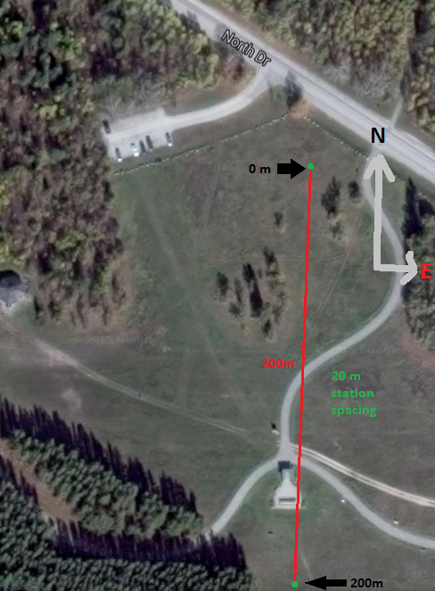

Figure 1. Elevation and Gravity survey layout.