PLNT2530 Plant Biotechnology

Lab - Agrobacterium tumefaciens Mediated Plant Cell Transformation
Name (ID#): Joe Shlobotnik (01234567) shlobj@myumanitoba.ca

PART 1.1 (20 points) Weekly Observations
For each week, fill in the number of days postinoculaton. Choose an image from those provided which best illustrates the changes from the previous week. Briefly describe what is different from week to week, and what evidence is seen for transformation and regeneration. Note important milestones eg. "This is the first time we see....".
Week 1 - __ days postinoculation
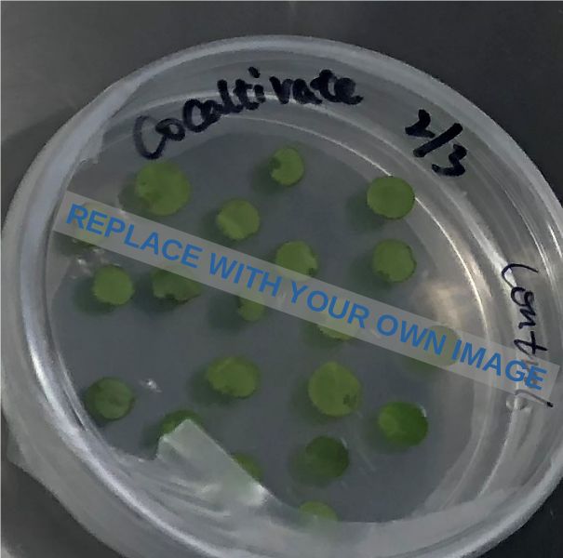 | 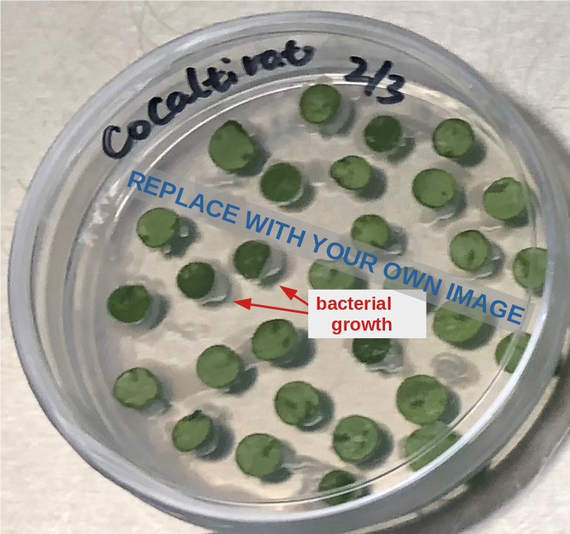
Control | Co-cultivated with A. tumefaciens

Week 2 - __ days postinoculation

Week 3 - __ days postinoculation

Week 4 - __ days postinoculation

Week 5 - __ days postinoculation

Week 6 - __ days postinoculation

Week 7 - __ days postinoculation

Week 8 - __ days postinoculation

Week 9 - __ days postinoculation

Week 10 - __ days postinoculation

