PLNT3140 INTRODUCTORY CYTOGENETICS October 2023

Karyotype Lab Assignment
Name (ID#) email: Joe Shlobotnik (01234567) shlobj@myumanitoba.ca
This assignment is worth 30% of the lab grade.
Due date: November 10, 2023

1. Annotated Chromosomes

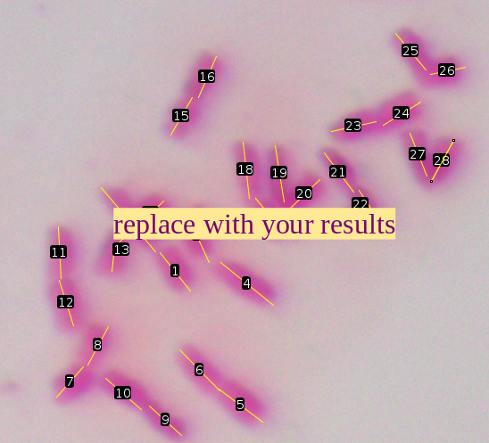
2. Karyotype Results

 |  | s | l | l/s | length (µM)
1 | 3.2 | 3.2 | 5.4 | 1.7 | 8.6
2 | 5.4
3 | 3.9 | 3.9 | 4.4 | 1.1 | 8.2
4 | 4.4
5 | 3.5 | 3.5  replace with your results | 3.7 | 1.0 | 7.2
6 | 3.7
7 | 2.6 | 2.6 | 2.8 | 1.1 | 5.4
8 | 2.8
9 | 2.8 | 2.8 | 3.1 | 1.1 | 5.9
10 | 3.1
11 | 3.3 | 3.1 | 3.3 | 1.1 | 6.4
12 | 3.1
13 | 3.2 | 2.3 | 3.2 | 1.4 | 5.4
14 | 2.3
15 | 2.8 | 2.8 | 2.9 | 1.0 | 5.7
16 | 2.9
17 | 3.1 | 3.1 | 3.7 | 1.2 | 6.8
18 | 3.7
19 | 3.7 | 2.6 | 3.7 | 1.4 | 6.3
20 | 2.6
21 | 3.2 | 3.2 | 3.9 | 1.2 | 7.1
22 | 3.9
23 | 2.9 | 2.8 | 2.9 | 1.0 | 5.8
24 | 2.8
25 | 3.1 | 2.3 | 3.1 | 1.3 | 5.4
26 | 2.3
27 | 3.0 | 3.0 | 3.0 | 1.0 | 6.0
28 | 3.0

3. Ideogram
