PLNT3140 INTRODUCTORY CYTOGENETICS September 2022

Mitosis Lab Report
Name (ID#): Joe Shlobotnik (01234567) shlobj@myumanitoba.ca
This assignment is worth 20% of the lab grade.
Due date: October 12, 2022

1. Interphase
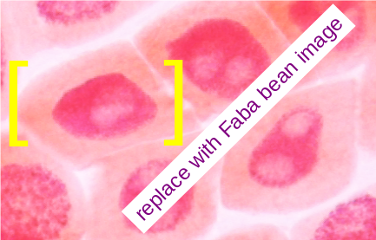Figure 1: sample.png
2. Prophase
Figure 2: sample.png

3. Metaphase
Figure 3: sample.png
4. Anaphase
Figure 4: sample.png

5. Telophase
Figure 5: sample.png

