Transportation and Urban Form

ARCG 7080 T04
Winter 2015
Fridays, 8:30 - 11:15

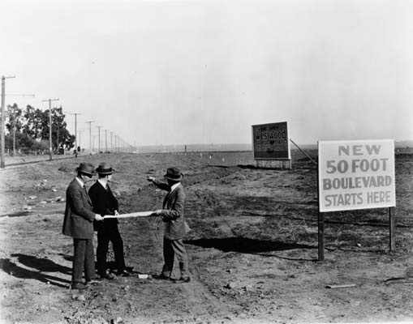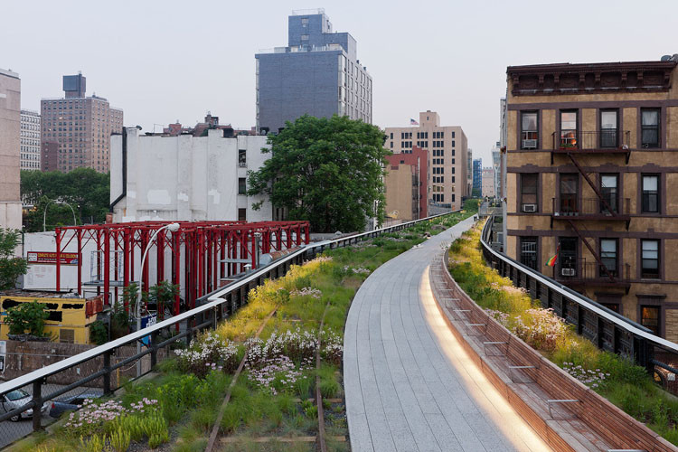
Los Angeles, 1922 High Line, 2009

Instructor: Orly Linovski
Office: Russell 317
E-mail: orly.linovski@umanitoba.ca
Phone: 474-6424

Office hours: Wed 10-11, or by appointment

1. Course Description
The debate around the need to reduce automobile dependency and congestion has led to an increasing interest in the relationship between urban form, travel behaviour and transportation infrastructure. This course focuses on the historic and contemporary interactions between land use and transportation from a variety of critical perspectives and methodological approaches. Understandings of Infrastructure as a generative process shaping urban development will structure our investigations into the movement of both goods and people.

The first part of the course traces the development of cities around various transportation investments, including railroads, streetcars, roads and highways, and examines the influence of infrastructure on residential and industrial development patterns. Building on this foundation, the next section looks at contemporary debates on the transportation effects of land use policies, exploring the research on travel behaviour, sprawl, and transit-oriented development. Finally, the last part of the class addresses equity and accessibility issues related to transportation and land use, including the jobs-housing mismatch, and the relationship between transportation and social exclusion.

2. Learning Outcomes

- To understand the relationship between land use, built form and transportation.
- Develop an understanding of the economic, legislative, and societal issues that affect the development of infrastructure systems.
- Develop evaluative and critical analysis skills.
- Refine writing and presentation skills.

3. Course Attendance

Classes are scheduled for Fridays, from 8:30 to 11:15 am, in Russell 211. This time will be used for the delivery of lectures and workshops on course material. Students are required to be present at all classes. Absence from more than two (2) sessions will be flagged for discussion with the instructor and may result in debarment from classes and examinations, in accordance with the University of Manitoba General Academic Regulations and Requirements.

4. Late Policy

Unexcused late submissions will be marked under the following penalty system:

Work not received on the assigned due date and time will have its grade reduced by one letter grade (i.e. from B+ to B).

Work not received within 3 days of the due date will receive a failing (F) grade.

5. Assignments

 | Issued | Due | % of Course Grade
Seminar Presentations | n/a | n/a | 30%
Assignment 1 | Jan 23 | Feb 27 | 25%
Assignment 2 (presentation) | Feb 14 | March 27 | 15%
Assignment 2 (written) | Feb 14 | April 17 | 25%
Participation |  |  | 5%

The evaluation of assignments will be based on criteria identified in individual assignment briefs as well as on the following general criteria:

- Demonstration of an understanding of the subject matter with respect to the course objectives.
- Ability to synthesize and integrate subject matter.
- Depth, clarity, and quality of submissions, including graphic and written presentation.
All assignments will be marked according to the Faculty grading schedule:

Letter Grade Grade Point Value Performance
A+ 4.5 Exceptional
A 4.0 Excellent
B+ 3.5 Very Good
B 3.0 Good
C+ 2.5 Satisfactory (graduate passing grade)
C 2.0 Adequate (undergraduate passing grade)
D 1.0 Marginal
F 0.0 Fail

6. Seminar Presentation
After a careful review of assigned readings, students will write a one-page summary of critical issues for distribution to the class. In addition, the students will select several examples or projects that embody some of the key issues they’ve identified. The projects and key issues will be presented in power point format, to initiate and guide class discussion.

The seminar presentations are intended to inspire critical thinking about the required texts and allow for productive discussion during class time.

7. Peer Review

Students are required to have a colleague in the class evaluate Assignment 1 before submission. You will be evaluated both on the quality of your review and how well you respond to the comments provided to you. This is optional but highly recommended for Assignment 2. Some class time will be devoted to this but if you are unable to attend that session, you are responsible for co-ordinating with a classmate.

8. Documentation of Sources

Sources for all data or illustrations must be properly credited. All Internet material must come from recognized organisations.

Please refer to A Manual for Writers of Term Papers, Theses, and Dissertations (Turabian, Kate L. 5th ed. Edited by Bonnie Birtwistle Honigsblum. Chicago: University of Chicago Press. 1987) for the appropriate documentation style.

A guide to proper citation formatting is also available at: http://www.chicagomanualofstyle.org/tools_citationguide.html

9. Procedures and Regulations

All students must conduct themselves according to the standards of academic integrity. Please refer to the current undergraduates and graduate Academic Calendars for the University of Manitoba’s General Academic Regulations and Requirements governing attendance, cheating and plagiarism, incompletes, appeals, academic suspension, and voluntary withdrawal from programs and courses. The Academic Calendars also reviews the University of Manitoba’s policies regarding the responsibilities of academic staff with regard to students, sexual harassment, University Ombudsman, and Student Advocacy and resource services.

Students are required to attend all course sessions and submit assignment on due dates. A medical certificate must be submitted to the course instructor if one is ill and unable to complete the assignments by a specified due date. Students are encouraged to set an appointment with the instructor outside of class time if they require additional feedback on their progress or on issues such as course content, procedures, or any other aspect of the course work.

The last day for voluntary withdrawal from this course without academic penalty is March 19, 2014. Please refer to the undergraduate and graduate Academic Calendars for the procedure involved. Students considering withdrawal are advised to seek an appointment with their course instructor to discuss their individual performance prior to this deadline.

Students are reminded that it is their responsibility to initiate an application for Incomplete Status (I) or Continuing Course (CO) in the course. Approval of an Incomplete Status or Continuing Course grade is not automatic and will depend on the assessment of the circumstances by the instructor. Assignments must be submitted on due dates regardless of their state of completion in order to be considered for Incomplete Status.

10. Schedule and Required Readings

Week | Date | Topic | Notes
1 | Jan 9 | Introduction  Evolution of Built Form and Transportation, Part 1: Rails
2 | Jan 16 | Evolution of Built Form and Transportation, Part 2: Roads
3 | Jan 23 | Transportation Effects of Land Use Policy | Assignment 1 issued
4 | Jan 30 | Urban Form and Travel Behaviour
5 | Feb 6 | NO CLASS – CAPS CONFERENCE
6 | Feb 13 | Parking
7 | Feb 20 | READING WEEK - NO CLASS
8 | Feb 27 | Public Transit and Land Use | Assignment 1 due  Assignment 2 issued
9 | Mar 6 | Transit-Oriented Development
10 | Mar 13 | Equity and the Spatial Mis-Match
11 | Mar 20 | Gender and Transportation | March 19 - Last day for Voluntary Withdrawal
12 | Mar 27 | Presentations
13 | April 3 | Good Friday – NO CLASS
14 | April 10 | MPPI Conference – NO CLASS

Readings

Week 1: Evolution of Built Form and Transportation Systems, Part 1 - Rails
Fulton, W. 1984. "Those Were Her Best Days": The Streetcar and the Development of Hollywood Before 1910. Southern California Quarterly 66 (3):235-255.
Moore, P. W. 1983. Public Services and Residential Development in a Toronto Neighbourhood, 1880-1915. Journal of Urban History, 9(4), 445-471.

Week 2: Evolution of Built Form and Transportation Systems, Part 2 - Roads
Brown, J. R. 2005. A tale of two visions: Harland Bartholomew, Robert Moses, and the development of the American freeway. Journal of Planning History 4 (1):3-32.
Hall, Peter. 1988. "The Automobile Suburb: Long Island, Wisconsin, Los Angeles, Paris, 1920‐1987," in Cities of Tomorrow. New York: Basil Blackwell. Pages 273‐318.
Wachs, M. 1984. Autos, transit, and the sprawl of Los Angeles: the 1920s. Journal of the American Planning Association 50 (3):297-310.

Week 3: Transportation Effects of Land Use Policy
Boarnet, M. G., & Sarmiento, S. (1998). Can land-use policy really affect travel behaviour? A study of the link between non-work travel and land-use characteristics. Urban Studies, 35(7), 1155-1169.
Giuliano, Genevieve (2004). “Land Use Impacts of Transportation Investments: Highway and Transit,” in The Geography of Urban Transportation, Third Edition, Susan Hanson and Genevieve Giuliano, Eds. New York: The Guilford Press. Pages 237-273.
Levine, Jonathan. 1999. “Access to Choice,” Access, 14: 16-19.

Week 4: Urban Form and Travel Behaviour
Biddulph, M. (2012). Street design and street use: comparing traffic calmed and home zone streets. Journal of Urban Design, 17(2), 213-232.
Boarnet, Marlon G. 2011. “Longer View: A Broader Context for Land Use and Travel Behavior,
and a Research Agenda,” Journal of the American Planning Association, 77(3): 197‐213.
Crane, R. 2000. The Influence of Urban Form on Travel: An Interpretive Review. Journal of Planning Literature 15(1): 3-23.

Week 5: CAPS conference

Week 6: Parking
Manville, M., & Shoup, D. (2005). Parking, people, and cities. Journal of Urban Planning and Development, 131(4), 233-245.
McDonnell, S., Mader, J., & Been, V. (2011). Minimum parking requirements and housing affordability in New York City. Housing Policy Debate, 21(1), 45-68.

Week 7: Reading Week/No Class

Week 8: Public Transit and Land Use
Cervero, R., & Landis, J. (1997). Twenty years of the Bay Area Rapid Transit System: Land use and development impacts. Transportation Research Part A: Policy and Practice, 31(4), 309-333.
Polzin, S. E. (1999). Transportation/land-use relationship: Public transit's impact on land use. Journal of Urban Planning and Development, 125(4), 135-151.
Pucher, John (2004). “Public Transportation,” in The Geography of Urban Transportation, Third Edition, Susan Hanson and Genevieve Giuliano, Editors. New York: The Guilford Press. Pages 199-236.

Week 9: Transit-Oriented Development
Cervero et al. (2004). Transit-Oriented Development in the United States: Experiences, Challenges, and Prospects. Transportation Research Board: Washington, D.C. Chapter 1 (pgs 3 - 11), Chapter 7 (119-138)
Loukaitou-Sideris, A., & Banerjee, T. (2000). The Blue Line blues: Why the vision of transit village may not materialize despite impressive growth in transit ridership. Journal of Urban Design, 5(2), 101-125.

Week 10: Equity and Spatial-Mismatch
Blumenberg, Evelyn. 2004. En‐gendering Effective Planning: Spatial Mismatch, Low‐Income Women, and Transportation Policy. Journal of the American Planning Association, 70(3): 269‐281.
Church, A., Frost, M. & K. Sullivan (2000) Transport and social exclusion in London. Transport Policy, 7, 195-205.
Kwan, Mei-Po (1999) Gender, the Home-Work Link, and Space-Time Patterns of Non-employment Activities. Economic Geography 75(4).

Week 11: Gender and Transportation
Giuliano, G., & Schweitzer, L. 2010. Her money or her time: A gendered view of contemporary transport policy; Conference Proceedings 46, Women’s Issues in Transportation, 1, 63-77.
Bostock, L. (2001) Pathways of disadvantage? Walking as a mode of transport among low-income mothers. Health and Social Care in the Community 9(1), 11–18.

Week 12: Presentations

