PLNT 2530 - Plant Biotechnology
Name
Student ID number
Assignment 4

1. Use BACHREST to generate a list of restriction enzymes that do NOT cut within the 5.3 kb PCR fragment for LepR3

Enzyme X: name X^XXXXX
Enzyme Y: name Y^YYYYY
Cutting sites in this example are arbitrary. Show the true cutting sites for your chosen enzymes.

2. (3 points) Modify your PCR primers to include unique restriction sites and at the 5' ends of both primers

Forward: 5'nnnnnnXXXXXXNNNNNNNNNNNNNNNNNNNN3'
Reverse: 5'nnnnnnYYYYYYNNNNNNNNNNNNNNNNNNNNNN3'
(Nucleotides added to the original primers are underlined.)

3. (3 points) Design left and right adaptors

Left adaptors (EcoRI/X)
A. Oligonucleotides  L1: 5'AATTCnnnnnnX3'  L2: 5'XXXXXnnnnnnG3' | B. How the oligonucleotides would pair in-vitro  5'AATTCnnnnnnX3'  3' GnnnnnnXXXXX5'

Right adaptors (Y/HindIII)
A. Oligonucleotides  R1: 5'AGCTTnnnnnnY3'  R2: 5'YYYYYnnnnnnA3' | B. How the oligonucleotides would pair in-vitro  5'AGCTTnnnnnnY3'  3' AnnnnnnYYYYY5'

4. (3 points) Plan your construct
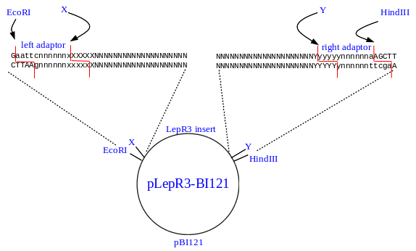
Replace this figure with your own image, created from construct_template.odt. Replace ambiguous nucleotides (eg. n,N,x,X,y,Y) with the actual sequences as described in part 4.

5. Digest pBI121 with EcoRI and HindIII

6. (3 points) In UGENE, create the X/Y restriction fragment for the PCR product.

Left
Right
Replace these images own cropped screenshots as described for part 6.

7. (2 points) Create your two adaptor sequences (2 points)

Left adaptor
Right adaptor
Replace these images own cropped screenshots as described for part 7.

8. (4 points) Assemble the completed construct

