Women don’t fish, or do they?

Strengths and Threats of Shrimp Catchers Sustainable Livelihoods in Vypin, India

Karen Peters and Shirley Thompson*, Natural Resources Institute, Clayton H. Riddell Faculty of Environment, Earth and Resources, University of Manitoba, Winnipeg, Canada.
Corresponding author: s_thompson@umanitoba.ca

Introduction
Fisheries, the world over, are under threat by global market demands and pressures (Shepard and Myers 2005). Not only is fishing under threat but the women’s role in artisanal fishing is, with a globalized economy, which devalues micro fishing for the local market (CSR, “The Impact of Trade and Globalization on Gender in India: A Case Study of Women Workers in the Fisheries Sector in Kerala & Gujarat”, Delhi, 2008.). Global market pressures affect food security and livelihood options at a local level. In the case of shrimp catchers, which is the role of women in the lowest or Pulya caste, in Kerala, India, in less than 40 years, their livelihoods involving catching fish for local consumption, have been negatively impacted by the pollution impacts of shrimp processing for the global market. As well, the traditional shrimp-based diet is reduced to export of this valuable commodity to the growing global demand for shrimp. Changes in global diets, as seen in the marketing of fish and seafood products, have a large and unexpected effect on traditional livelihoods and diets.
Livelihood refers to the assets, capabilities and activities essential for a means of living (Rennie and Singh 1996). Livelihoods are at risk from the pressures of globalization/global markets that include their environmental impacts on local ecosystems. Specifically with fisheries, large global interests have been shown to have wiped out fish, thus fisheries in many parts of the world are in demise. The small-scale artisanal fishers and the ecosystems where they work are greatly affected.
The world over, women fish, yet their labours are undervalued or ignored. This research focused on local small-scale fisheries in Kerala, South India, by observing and interviewing shrimp fishers, who are mainly women to 1) document resource use and livelihood activities in the Vypin Island in Kerala, India; and 2) undertake a gender analysis of local economic and livelihood activities. An interest in applying gender analysis to traditional fishing livelihoods was piqued by finding little information on women and fisheries to the extent that the literature proclaimed “women do not fish” (Pisua and Leonard 1998; Ruddle 1994).
To date, very little has been written worldwide about women’s interactions with coastal resources (Pisua and Leonard 1998, Ruddle 1994). However, the resources that women use within coastal communities, the manner of their use, and their access to these resources, are unique, generally compared to those of men (Matthew 1997). Gender differences determine access to different types of fisheries with women typically not allowed as fishers on the seas in the larger boats. In most regions of the developing world the large boats used to fish offshore and deep-sea waters have male crews, while women are relegated to inshore and inland fishing. Women engage in fishing with small implements, harvesting the shores for shellfish and other species. It is a common misconception that “Women don't fish; they just gather shells” (Tuara 1996). Women, however, do engage in many aspects of fishing and both men and women sell fish but it is usually the women who process the fish, presently and traditionally.
Of importance to understanding livelihood options is an understanding of the role that gender plays in determining options available for livelihoods. In Africa, women fish the rivers and ponds. In Laos, women fish in canals. In the Philippines, women fish from canoes in coastal lagoons (Tuara 1995). In the various Pacific Islands cultures, women are involved in deep-sea fishing alongside men, community fishing, reef gleaning and freshwater trapping activities (Tuara 1996). In parts of India, women net prawns from backwaters.
This research attempted to document shrimp-catcher’s livelihoods in Vypin, India, and elucidate women’s roles in local decision-making processes. In this participatory research on sustainable livelihoods of lower caste women, an ecofeminism and feminist political ecology analysis are undertaken. Vandana Shiva (1989) links the subordination of both women and the environment with global political structures and ideologies stemming from patriarchy. In this ecofeminist analysis, environmental destruction is associated with masculinity while the feminine work is associated with preservation of life. Women’s struggle for survival is linked to the struggle for the protection of nature because “women and nature are intimately related, and their domination and liberation are similarly linked. The women’s and ecology movement become one, and are primarily counter-trends to a patriarchal maldevelopment” (Shiva 1989, p. 47). Women are linked with nature by virtue of their reproductive abilities and the key responsibilities within the reproductive sphere such as women’s roles looking after the family, providing food, childrearing and nurturing. Shiva exposes maldevelopment, as a development that facilitates ecological destruction and the marginalization of women. Many systemic constraints are faced by women as environmental managers in an international political economy which perpetuates the extraction of resources from disadvantaged people in less developed countries for the purpose of capitalist expansion.
New feminist insights emerged from the work of feminist political ecologists who offered a critique of ecofeminism, as all women do not, however, experience the same oppression or the same challenges of environmental degradation. Women are divided by class, age, status, seniority, divisions of labour, access to, and control of, resources and decision-making power (Jackson 1993). Feminist political ecologists argue that gender is one variable in shaping access to, and control of, natural resources. In the feminist political ecology approach, gender interacts with class, caste, race, culture, and ethnicity to shape processes of ecological change and sustainability. Furthermore, women have both positive and negative environmental agency and thus, have no inherent affinity to nature and environmental preservation. Rather, women’s relationship with natural resources is socially constructed and varies among groups of women and between individuals, and this relationship changes over time (Jackson 1993, Rathgeber 1995). Feminist political ecology brings together feminism with an analysis of ecological, economic and political power relations (Rocheleau, Thomas-Slayter and Wangari 1996).
The focus of this paper is women shrimp catchers, pulse fishing, without nets. The shrimp catchers engage in what is known as the household mode of production (Wilk 1989), with their hands being the gear to catch the shrimp. These activities aided the local domestic market as opposed to the shrimp processing and fish processing activities that were geared for export.
This study was conducted on Vypin, a narrow 27 km long island off Fort Cochin situated between the Arabian Sea and the Cochin Backwater. In terms of fishing, Kerala is a very significant region. With 10% of India's coastline and 7% of India's continental shelf, the state produced 24% of the total marine catch and accounted for some 40% of India's seafood exports in the 1980s (Meynen 1989). In the early 1960s, artisanal fishers in Kerala numbered about 85,000 (NCAER 1962); by the 1980s that figure was over 106,000 with an additional 17,500 workers in the mechanized fisheries sector (Kurien, 1985). In the 1980s, the artisanal fishers had some 34,000 water craft and produced over 60% of the marine catch while there were about 3,000 mechanized boats in the 'modern' sector (Meynen 1989). These larger mechanized boats can cast deep nets and fish out further in the open ocean.

Method
The approach of this research is participatory, working with local communities toward the development of sustainable livelihood strategies. By working with local researchers, the Grama Vikas Society, as well as Melukavumattom, I attempted to connect the shrimp catchers to enabling non-government organizations (NGOs). A number of one-on-one and semi-directed interviews and focus groups were conducted with each one of the 19 full-time female shrimp catchers, five part-time female shrimp catchers and one male shrimp catcher, regarding sustainable livelihoods. A time survey with the 19 full-time shrimp catchers was carried out. The shrimp catchers were interviewed at their early morning catching time as well as at the market, and often at their homes. Karen Peters, student researcher, also watched and participated in the shrimp catching as well as observing market activity. In 2003 Karen Peters observed the livelihoods of the shrimp catchers, revisiting the situation in 2007, enquiring about the social, environmental and economic changes that may have taken place in the last four years. This research attempted to contribute to the empowerment of local women by acknowledging their knowledge, priorities, and concerns, and communicating them back as findings in focus groups.

Shrimp Catchers livelihood
All the shrimp catchers interviewed used the Thappiyedukkal method, a Malayalam word for the method of catching shrimp by sensing vibrations by hand, without fishing gear. Shrimp were caught, without gear, feeling in the canals for movement, a technique of catching by sense of touch or pulse fishing. Pulse fishing and knowledge of fishing cycles were passed on for many generations. Most women reported being self-taught in catching shrimp, learning by watching their mothers and grandmothers. Shrimp catching had low input costs, as the women do not use any gear other than their hands to catch the shrimp. They fished in open access canals typically. “First-comer’s rights” or rights to fish in an area by arriving first determines who fishes where. Catching shrimp in the canals was done without paying rent as canals were open-access canals. The women often worked in groups at a small distance from one another and moved, as a group, down the canal at the same time. They were co-operative and supportive rather than competitive. Despite there being more shrimp catchers, the catch declined according to interviews.

Insert Figure 1 and 2.

The women carried out the entire production and marketing without requiring to purchase inputs or external modes of production. Women caught the shrimp and then did the marketing immediately with no middleman. This lack of middleman meant they made and retained on average 40 INR (India Rupees) which equals less than $1.00CAD – so these woman and often their entire families, if they were the sole breadwinner, typically lived on less than $1.00 per day. In the marketing aspect, women did not require any inputs in selling other than newspapers and occasionally some plastic bags. As the catch was marketed daily, ice was not required. The location of Vypin provided a ready market for selling the shrimp, as it was in the most densely populated area of Kerala (some say of Asia), although having a rural nature. Only the day’s catch that had not been sold at market was processed. Processing included peeling and drying that day’s catch. The processing, when needed, was all done by the same shrimp catchers.
The shrimp catchers had their own catch to supplement their diets, with by-catch of small fish or small crab also a key part. Any large species were sold. Harvesting local varieties of rice were integrated with the shrimp cycle, in their work, as shown in Figure 3, as well as in their diet. Most women had gardens containing an abundance of plant species which would also supplement their diet. These local gardens and the fisheries supplied most of their food, as there was little cash income to buy food. In addition, the gardens and fisheries provided the local markets that fed the majority of the population’s caloric intake. However, the demands of globalization had, in effect, changed the local diet and up to 90% of the shrimp yield was exported.
Shrimp catching was an activity that only women of the lowest caste participated in, traditionally. Although there was no evidence of women in Vypin sea fishing from large boats, occasionally men did inland fishing, although they typically have more lucrative options. For example, one man was observed to be catching shrimp because he had lost his job and his wife was too ill to catch shrimp. He restricted his activities to the canals surrounding the community.
The shrimp catchers described themselves as entrepreneurs and are very proud of their independence. However, the shrimp catchers all stated that they did not want their children doing this type of work. They wanted a better life than this harsh life which provided only a meager income. The women lived on $1.00 per day and had no savings, either individual or group savings. The shrimp catchers don't make a great living; it is just above subsistence. Were there to be any shocks to their health or the ecosystem, they have no means to deal with it. However, the shrimp-catchers did try to take care of each other despite being the most financially disadvantaged in the area. In September 2006 all 20 full-time shrimp catchers, joined a union. This union provided a savings plan for advanced education to their children as well as having in place a program to provide for health emergencies. Their small monthly union dues provided much needed health benefits and security should they become ill or injured, and it offered advanced education for their children. Kerala boasts an excellent education system with almost 100% literacy rates of children. Children were encouraged to go to school, and no matter what class had a chance to achieve higher education. Some of the younger women participated in shrimp catching on a part-time basis while attending school.

Seasonal calendar of women’s livelihoods

Shrimp catching in canals was done all year round as shown in the seasonal calendar portrayed in Figure 3. During medium or low season, when yields were less, some of the younger shrimp catchers would work in the shrimp peeling sheds as labourers. The months from April to beginning of June was the peak season for shrimp catching, with harvests occurring in both canals and pokkali rice fields. For only three months shrimp are harvested in Pokkali rice fields. More than half of the shrimp catchers relied very heavily on shrimp catching and would plant Pokkali rice for only two weeks in the year. Some of the younger shrimp catchers would also be involved in the rice harvest as well as harvesting shrimp from the paddies during the high season. When they caught the shrimp in the paddies, they would often have a payment arrangement with the owner of the field or be allowed to glean the shrimp and rice from the paddies at the end of the harvest.

Insert Figure 3

Time survey of shrimp catching women

As seen in Table 1, 19 full-time female shrimp catchers in their time surveys indicated they worked between 13 and 18 hours daily. The women’s long days involved a lot of physical labour, without labour saving devices such as running water or refrigerators. Female shrimp catchers’ work was also increased during tidal times by five hours on average. Shrimp catchers catch shrimp according to tidal times, which change with the moon. Thakkam time is the lunar cycle for fishing in the full-moon period, which lasts about four days. During the Thakkam time the shrimp catchers fished twice as often, sometimes in the middle of the night. Yields were better during the full moon, with at least twice the catch, and even higher during the trawling ban. During the lunar catch time, the amount of labour for all local fishers increased to take advantage of better yields, thus requiring more shrimp peeling work and marketing to sell the larger yield.
Many of the shrimp catching women were the poorest of the poor and the primary “breadwinner”, solely supporting their households. Below several women’s schedules are described to show how their households were dependent on their housework for water, food and sanitation but also their income. Sarasu, age 52, had eight members in her household. Shrimp catching was the main source of income as her husband was paralyzed and her two sons were unemployed. Her two daughters-in-law, however, were also shrimp catchers. In addition to the shrimp catching Sarasu sometimes undertook daily wage jobs, to supplement her meager income. As well she had the main responsibility for household chores. Her daily activities started at 6:00 a.m. when she did one hour of household tasks, followed by three hours of shrimp catching, two to three hours at the market, and then three hours of more household tasks plus one hour gathering firewood. In addition, she hauled water three hours per day.
Indira, age 42, previously had worked as a construction labourer, but had experienced pain that prevented her from keeping that position. With few other possibilities, she turned to catching shrimp. She was not married and supported her mother and herself, with the household having no other source of income. She rose each morning at 5:00 a.m. and began fishing at 6:00 a.m. She was also responsible for the household tasks which she completed in about three hours. She caught shrimp for three hours, spent three hours at the market, and worked three hours hauling water.
The other women’s time surveys were very similar. Many of the women worked at the processing plant seasonally, eventhough the processing plants for exported shrimp polluted the canals that the women worked in. This option compensated marginally for the loss in income from their independent fishing.

Environmental Threats
The working environment of the shrimp catchers was changing, threatening their livelihoods. The Panachat (Hindu name for local government officials) were threatening in 2003 to dredge the lagoons, to deepen the canal for traditional fishers (men) with boats. For the women shrimp catchers this threatened to terminate their ability to catch shrimp in the canals as the deeper water would put them underwater and the women could not swim. The canals had not been dredged yet in 2007, when the area was revisited, and the women still caught shrimp but were still under threat of this occurring. Although their livelihoods were at risk, they were not part of this political process or other local political decision-making processes that would physically, socially or economically affect them. They did not feel they would be listened to with their limited education and lower caste and felt the political process was against them. Also, no non-government organizations were involved with the shrimp catcher’s poverty and livelihood issue.
Other environmental changes were the increasing pollution and fish depletion from a globalized economy promoting large-scale developments. This pollution has been steadily increasing since the 1970s. Prior to 1970, Kerala’s fisheries were dominated by small-scale, local entities, providing fish and shrimp for local consumption. After 1970 global demands for shrimp changed the way communities in the area accessed and used these fisheries resources. Development aid from Norway provided large trawlers and dragnets to increase the catch of the area for a global market. While the introduction of larger fishing vessels brought about a depletion of the fish stock in the open coast, its impacts were also felt by the communities continuing in the traditional small-scale production areas. However, it should be noted that the Kerala government refused to develop large-scale intensive shrimp farms, recognizing that they are ecologically disastrous from earlier ventures. Alternatively, the government pursued large scale shrimp catching from boats as an export economic path and developed small and large-scale fisheries and fishponds for aquaculture in the mangrove habitats.
According to focus groups and interviews the three primary changes that the shrimp catchers had experienced were:
- Decreased food quality: The taste of shrimp was not as clean tasting, which they attributed to the fuel pollution of the trawlers into their waters.
- Diminished quantity of fish: The growth in factories and industries, particularly the surge of fish and shrimp processors, in the area polluted the canals with their toxic effluent resulting in shrimp and fish dying. These plants geared to the export market polluted the canals with freezing chemicals and bio-waste, such as shrimp peels and spent freezing chemicals. Many women described this “pollution killing off entire catches”. The bio-waste from sheds crowded the canals, often blocking them off from immature shrimp to enter as part of the shrimp lifecycle. The shrimp quantities were reported to be declining.
- Polluted environment where they work: Many of the women experienced skin rashes and other reactions from working in canals where refrigeration effluents had been dumped. There was also the problem of bio-waste and effluents from the shrimp-peeling sheds, creating high bacterial counts with all the waste fish parts.

Conclusion

In looking at the livelihoods of women from the lowest caste in a developing country much insight is gained about environmental impacts of the global economy and the marginalization of the poor. The female shrimp catchers work in a sustainable manner, providing food for local markets surrounded by economic development that threatens their livelihoods. The health of the canals where they catch shrimp was under threat from environmental change due to pollution and overharvesting by large operations. This maldevelopment was facilitating ecological destruction and the marginalization of these lower caste women. Many systemic constraints, including economic, environmental and social were faced by these women as environmental managers who have open access rather than proprietary or political rights to fish for shrimp. The shrimp catchers’ lack of power to protect the ecosystem that they depend on for their livelihoods also creates health risks by working in polluted areas. The shrimp catchers had a sense of powerlessness in working against the rich, wealthy and powerful polluters, as the catchers themselves were of the lowest caste, poor and without power.
The shrimp catcher’s livelihoods are precarious with little resilience to environmental, social and economic changes. Many of the women are the family breadwinner with no cash reserves and few entitlements. The shrimp catchers work long hours for little economic reward and are doubly burdened by household chores and fetching water at home, without modern conveniences to lessen their burden. The women’s livelihoods are at risk, given their strong reliance on shrimp catching as their singular livelihood, with only brief periods of rice planting and other employment. However, the recent joining of the union provided some security, should they fall ill, or the opportunity for their children to attend school, to have other livelihood options.
Corporate interests put a great deal of pressure on the ecosystem and the livelihoods of the shrimp catchers. The traditional diet has been changed as shrimp, which was once a staple food, is now being caught predominantly for export. This has an impact on caloric intake and nutritional health if there is a reduction in proteins. Although the global demands have already wiped out artisanal fisheries in other parts of the world, Kerala continues to have subsistence fishing of shrimp. Although Kerala has refused to develop large-scale intensive shrimp farms, recognizing that they are ecologically disastrous, they have pursued large scale shrimp catching. This impacts the small-scale artisanal fishers and the ecosystem where they work by pollution diminishing the stock. However, the shrimp peeling industry provides much needed seasonal income for traditional fishers and so are not required to change. This new employment of the global market generated poor quality of employment for women, which is not on economic terms equal with men, and in conditions of work that have not, so far, created positive change in their situation within the home or outside of it but created negative change, threatening health and livelihoods.
To date, efforts to limit the timing and the catches of the trawlers and the size and type of their fishing gear to ensure that yields are sustainable has not been effective. Although there are strict national and state laws, they are not enforced, yielding to pressures of oil development and commercial fisheries. Furthermore, little had been done to address the supporting industries of these trawlers, such as the shrimp peeling and refrigeration waste pollution.
Changes must occur soon, or the fisheries will collapse. Locally, strengthening the rules that govern fisheries is needed. Consideration should be given to the rights of women to work in canals and to prevention of dredging in favour of men’s interests in boating. Strict regulation of the effluents of processing plants is also needed. Demanding accountability of multinational fisheries companies would be required. Any solution that would ease the pressure would have to involve local and international efforts.
Bibliography

Carr, M., Chen, M. and Jhabvala, R. (eds.) (1996) Speaking Out: Women’s Economic Empowerment in South Asia, Delhi: Vistaar.
Chambers, R., 1983. Rural Development: Putting the Last First. Essex: Longman, Science and Technical.
Chambers, R., 1997. Whose Reality Counts: Putting the First Last. London: Intermediate Technology Publications.
Elliot, L., 1996 Women, Gender, Feminism, and the Environment. The Gendered New World Order: Militarism, Development, and the Environment. New York, 1-15.
Elliot XXXInitial and Elliot, J. A., 1994. An introduction to sustainable development. London: Routledge.
Jackson, C., 1993. Doing what comes naturally? Women and environment in development. World Bank 21, no. 12:1947-63.
Kurien, J.,'Technical assistance projects and socio-economic change. Norwegian intervention in Kerala's fisheries development', EPW, vol. 20, nos. 25 & 26 (22-29 June 1985), pp. A77-79
Merchant, C., 1995. Earthcare: Women and the environment. London: Routledge.
Meynen,W., 'Fisheries development, resources depletion and political mobilization in Kerala: the problem of alternatives', Development and Change, vol. 20 (1989), pp. 738-39 pp. 738-43
National Council for Applied Economic Research, Techno-Economic Survey
of Kerala (New Delhi: NCAER, 1962), p. 82
Pisua, L. and Leonardo, A., 1998. Peruvian Fisheries, Women can Fish too, Samudra, December 1998
Rao, A.and Kelleher, D., 2003. Institutions, organisations and gender equality in an era of globalization. Gender and Development 11, no. 1:142–49.
Rathgeber, E. M., 1995. Integrating gender into environmental education in Africa. Canadian Journal of Development Studies [Special Issue]:89-103.
Rathgeber, E., 1990. “WID, WAD, GAD: Trends in Research and Practice”, Journal of Developing Areas , 24 July: 489 – 502.
Rennie, K. and Singh, N., 1996. Participatory Research for Sustainable Livelihoods: A Guidebook for Field Projects. Winnipeg: IISD.
Rocheleau, D., Thomas-Slayter, B. and Wangari, E. (eds.) 1996. Gender and environment: A feminist political ecology perspective. In Political ecology: Global issues and local experiences, 3-23. London: Routledge.
Ruddle, K., 1994. “Venezuela, Pacific Basin, and Virgin Islands”, Folk Management in the World’s Fisheries. Christopher L. Dyer and James R. McGoodwin (eds.) University Press of Colorado.
Shiva, V., 1989. Staying alive: Women, ecology and survival. London: Zed Books.
Tuara, P. N., 1995. The participation of women in fisheries in the South Pacific. 4 pp Paper presented at the SPC regional workshop on the role of women in fisheries development, Iloilo City, Philippines, 17-21 July 1995.
Tuara, P. N., 1996. Women's fisheries development section: supporting women in fisheries. Paper presented at the South Pacific Commission Twenty-sixth Regional Technical Meeting on Fisheries, Noumea, New Caledonia, 5-9 August 1996. SPC/Fisheries Information Paper 11. p. 5
United Nations Development Programme, 2002. Human development report. New York: Oxford University Press.
United Nations ECOSOC Report, 2002. Gender mainstreaming: An overview. New York: United Nations.
United Nations Food and Agriculture Organization. web site: www.fao.org, 1997.
Walby, S., 2005. Gender mainstreaming: Productive tensions in theory and practice. Social Politics 12, no. 3:321-43.
Wilk, R. 1989. The Household Economy: Reconsidering the Domestic Mode of Production, 1989.
Figure 1 Shrimp Catchers entering canal. Photo credit: Karen Peters, 2002.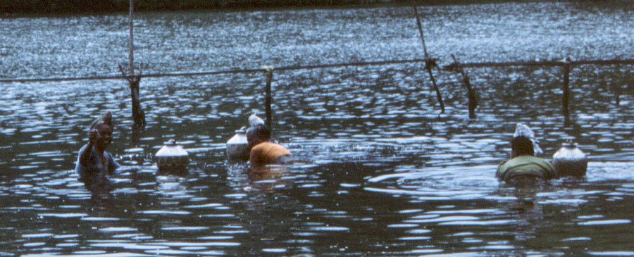

Figure 2 Shrimp Catching Practice in Tidal Canals with Three Women side by side 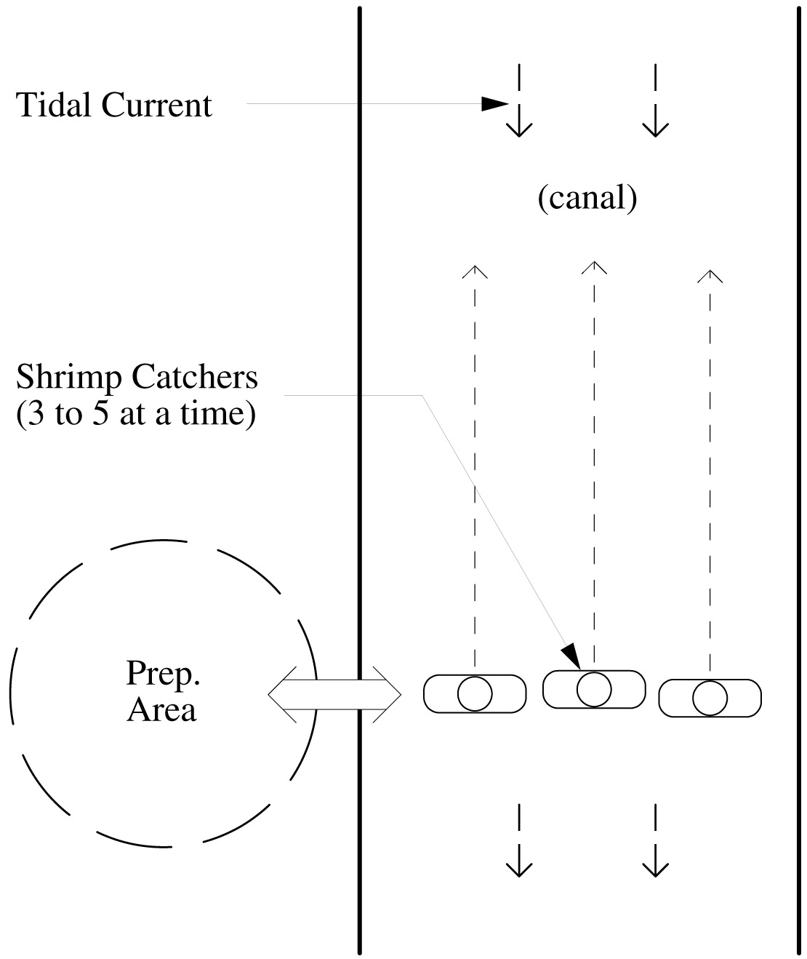
Figure 3: Seasonal Activity for Shrimp Catchers 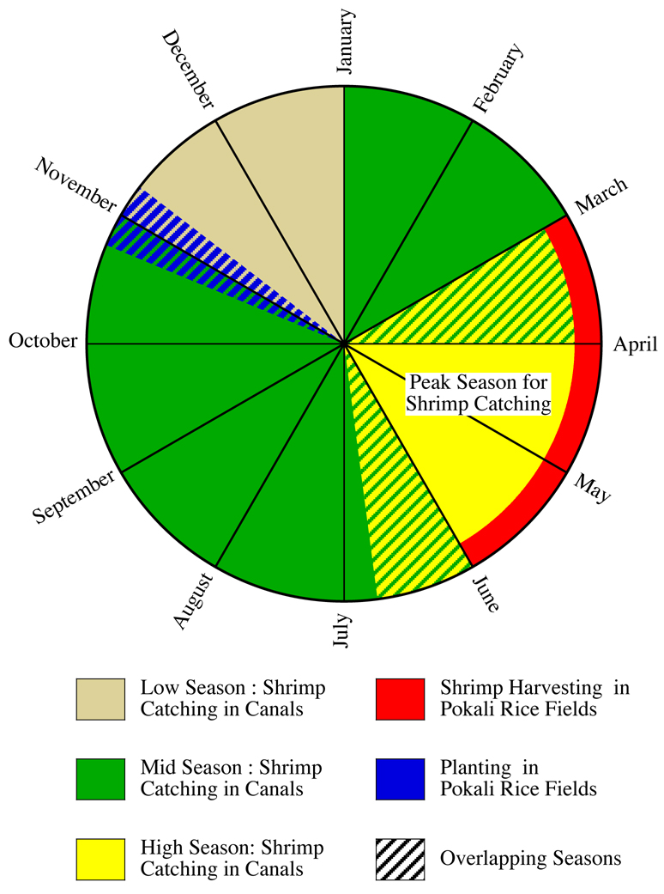

Table 1: Results of Time Survey of Female Shrimp catchers’ daily activities
(mean hours per day averaged for 19 full-time shrimp catchers (n=18))

Activity/  Time spent (mean hours/day) | Household chores  (hours/day) | Catching Shrimp  (hours/day) | Marketing shrimp  (hours/day) | Hauling water  (hours/day) | Total per day (hours/day)
Regular catching time  X=20 | 3.8 | 3.66 | 3 | 3 | 13.46
Lunar catch (thakkam) time | 4 | 6 | 5 | 3 | 18

