Geographical variation in the incidence of childhood leukemia in Manitoba

Mahmoud Torabi¹, PhD; Harminder Singh^{1,2}, MD; Katie Galloway¹, MSc; Sara J. Israels³, MD
Department of Community Health Sciences, Department of Internal Medicine, Department of Pediatrics & Child Health
University of Manitoba

Running title: Spatial patterns and predictors of childhood leukemia
Word count: 2,424
Number of Tables: 3
Number of Figures: 6
Corresponding author:
Mahmoud Torabi, PhD
Department of Community Health Sciences, University of Manitoba
S113 Medical Services Building, 750 Bannatyne Ave.,
Winnipeg, Manitoba,
Canada R3E 0W3,
Telephone: 204 272 3136 FAX: 204 789 3905
E mail: Mahmoud.Torabi@umanitoba.ca
Keywords: Childhood leukemia; geographic epidemiology; spatial patterns

Background: Identification of geographical areas and ecological factors associated with higher incidence of childhood leukemias can direct further study for preventable factors and location of health services to manage such individuals.
Aim: To describe the geographic variation and the socio demographic factors associated with childhood leukemia in Manitoba.
Methods: Information on childhood leukemia incidence between 1992 and 2008 was obtained from the Canadian Cancer Registry and the socio demographic characteristics for the area of residence from the 2006 Canadian Census. Bayesian spatial Poisson mixed models were used to describe the geographical variation of childhood leukemia and to determine the association between childhood leukemia and socio demographic factors.
Results: The south-eastern part of the province had a higher incidence of childhood leukemia than other parts of the province. In the age and sex-adjusted Poisson regression models, areas with higher proportions of visible minorities and immigrant residents had higher childhood leukemia incidence rate ratios. In the saturated Poisson regression model, the childhood leukemia rates were higher in areas with higher proportions of immigrant residents. Unemployment rates were not a significant factor in leukemia incidence.
Conclusion: In Manitoba, areas with higher proportions of immigrants experience higher incidence rates of childhood leukemia. We have identified geographical areas with higher incidence, which require further study and attention.
What is already known in this topic What this paper adds
1 The etiology of leukemia is believed 1 We proposed an approach to study
to be a combination of genetic and the geographical variation and ecological
environmental factors. factors associated with childhood leukemia.

2 The incidence and survival outcomes 2 The southeastern part of Manitoba had a
of children with leukemia vary with ethnicity. higher incidence of childhood leukemia than
other parts of the province.
3 In Manitoba, we identified some areas with
higher proportions of immigrants that had
increased rates of childhood leukaemia.

Acute leukemia is the most common cancer among children [1,2]. The incidence is rising in North America [3]. The incidence and survival outcomes of children with leukemia vary with ethnicity [2]. In the United States, children of African American descent have a lower incidence of acute lymphoblastic leukemia (the most common form of acute leukemia in childhood) but also have lower survival outcomes compared to European Americans and Asian Americans [2].
The etiology of leukemia is thought to be a combination of genetic and environmental factors. Previous studies have suggested that socioeconomic status plays a role in the incidence [1] and survival rates of leukemia [4].
Canada is a multicultural country with an ethnically diverse population. Approximately 4 and 16 percent of the total Canadian population are First Nation and visible minorities, respectively. In Manitoba, approximately 13 and 10 percent of the population are First Nation and visible minorities, respectively [5,6]. To the best of our knowledge, there are no data on the geographical variation in the incidence of childhood leukemia in Canada.
Identification of geographical areas [7] and ecological factors associated with higher incidence of childhood leukemias can direct further study of possible preventable factors and may inform the need for health services in particular geographic regions. The objectives of our study were to determine the geographical variation and ecological factors (characteristics of the neighborhood of residence) associated with childhood leukemia in Manitoba.

Methods
Data sources and study measures
Manitoba is a central Canadian province with an area of 649,950 square kilometers with a relatively stable population (1.11 million in 1992 and 1.2 million in 2008). The climate and terrain in Manitoba are quite diverse. Southern Manitoba experiences cold winters and warm summers, while the temperatures in northern Manitoba are typically much cooler than the southern parts of the province. The climate and terrain in southern Manitoba is conducive to agriculture in the summer, while the vegetation in the northern region ranges from coniferous forests to tundra. For this reason, most of the people in this province live in southern Manitoba. In 2008, 72,000 people lived in northern Manitoba [8]. Data from Statistics Canada on the population counts in the province were used to determine the population size and distribution across the province.
Information regarding leukemia diagnosis was obtained from the Canadian Cancer Registry (CCR) [9], a copy of which is housed in the Research Data Centre at the University of Manitoba. The CCR is a population based database actively recording all cancers diagnosed in residents of Canada. Reporting to the CCR is mandated by law and the coding and capture of cancer data in individual provincial cancer registries are audited regularly by the North American Association of Central Cancer Registries. The quality of the CCR data is high with consistently high levels of reporting completeness for the individual provincial registries. Information on acute leukemia diagnosis was obtained from the CCR for all children less than 15 years of age, who resided in Manitoba and had leukemia diagnosed between 1992 and 2008. Cases of leukemia were identified using the International Classification of Diseases for Oncology, 3rd Edition (ICD-0-3) codes 9826, 9835-9837, 9840, 9861, 9866, 9867, 9871-9874, 9895-9897, 9910, 9920, and 9891. These codes represent Acute Lymphocytic Leukemia and Acute Myeloid Leukemia (ALL and AML) cases. Age at diagnosis was used in the study. Since the data accessible to us from Statistics Canada on population counts and distribution across the province was aggregated in 5 year age bands, we limited the analysis to children diagnosed with leukemia before the age of 15.
The province of Manitoba consists of five Regional Health Authorities (RHAs) and is further sub-divided into 67 RHA districts (RHADs). These 67 areas were the geographical units used in the analysis. The six digit postal code of residence at time of diagnosis was used to geocode each leukemia case to 67 Regional Health Authorities Districts (RHADs).
Socio demographic characteristics (proportion of immigrants, visible minority status, unemployment status, and aboriginal status in each unit area of the study), were obtained from the 2006 Canadian census microdata files [10]. Unemployment rate was defined as the percentage of the population in the labour force (persons actively looking for work aged 15 and older) in the area who were unemployed in 2006. Aboriginal rate was the percentage of the population reporting aboriginal status in 2006 (including North American Indian single ancestry, North American Indian and non-Aboriginal ancestries, Métis single ancestry, Métis and non-Aboriginal ancestries, Inuit single ancestry, Inuit and non-Aboriginal ancestries, and other Aboriginal multiple ancestries). Proportion of immigrants was the percentage of the population reporting in 2006 that they immigrated to Manitoba from outside Canada since 1961. Proportion of visible minority was the percentage of the population reporting visible minority (including Chinese, South Asian, Black, Filipino, Latin American, Southeast Asian, Arab, West Asian, Korean, and Japanese) status. We defined the proportion of visible minority immigrants as the percentage of population reporting visible minority and immigrant status in each area.

Statistical analysis
The geographical variation of childhood leukemia incidence was modeled using a spatial Poisson mixed model to calculate age and sex standardized rates. Possible unstable rate estimates stemming from small numbers of cases in areas with small populations were controlled for by smoothing the rate estimates using Bayesian spatial Poisson hierarchical models. These models included two random variables indicating the geographical variation and any other unspecified variation across the study region [11]. The incidence rate was smoothed by gathering information from neighbouring regions in order to provide stable rate estimates [12]. The Bayesian models used in this study are discussed in detail elsewhere [13]. ArcGIS version 10.2 (Environmental Systems Research Institute, USA) was used to create choropleth maps.
The relationship between childhood leukemia incidence and the characteristics of the RHADs was modeled using two methods. First, a series of age and sex-adjusted Bayesian spatial Poisson regression models were developed. A second approach was applied using a saturated Bayesian spatial Poisson regression model, which incorporated multiple predictor variables (visible minority, aboriginal status, immigrant, and unemployment rate). The models were fitted to individual cases, in which the cases were assigned the socio demographic characteristics (e.g. percentage of visible minority) of the area of residence (RHAD). The predictor variables and the smoothed incidence rates of childhood leukemia were categorized into levels based on a Jenks natural breaks classification approach [14]. In addition to incorporating a spatial variation into the model, a random variable was also used in the model to capture the unspecified variation across small areas to manage possible over-dispersion. The results are presented as incidence rate ratios (IRR) and are based on the posterior probability and the corresponding 95% credible interval, which is the Bayesian equivalent to a confidence interval using the frequentist approach.
The University of Manitoba’s Research Data Centre approved the study, and Statistics Canada approved administrative data access. The models were implemented using the WinBUGS software package [15].

Results
A total of 88 boys and 80 girls diagnosed with acute leukemia between 1992 and 2008 were identified. Table 1 shows the childhood leukemia counts and crude rates (per 100,000) per year. The rates were highest for children between 0 and 4 years of age, were lower for children aged 5 to 9 years of age and were lowest in those 10 to 14 years of age.
Figure 1 depicts the socio demographic characteristics of the RHADs in Manitoba, based on the 2006 Canadian Census data. The percentages of Aboriginal people and unemployment rates were highest in Northern Manitoba (Figures 1a and 1b). The percentage of immigrants was highest in Winnipeg and south-eastern Manitoba (Figure 1d). As shown in Figures 1c and 1e, the percentages of visible minorities and visible minority immigrants were highest in Winnipeg.
The choropleth map in Figure 2 shows the smoothed incidence rates of childhood leukemia across Manitoba. The rates ranged from 1.4 and 9.7 (per 100,000) per year and the highest rates were in the south-eastern part of Manitoba, while most of northern Manitoba had lower leukemia rates. When comparing the smoothed incidence rates in Figure 2 with the socio demographic factors in Figure 1, the incidence rates appear to be higher in regions where there were higher percentages of visible minorities and immigrants. Some (although not all) regions with a higher proportion of Aboriginal people had lower incidence rates of childhood leukemia.
Table 2 represents a series of the age and sex adjusted spatial Poisson regression models for leukemia from 1992 to 2008. Areas of the province with higher proportions of individuals of visible minority or immigrants had higher rates of childhood leukemia. Similarly, areas with higher proportions of individuals with visible minority immigrants experienced increased childhood leukemia incidence. Aboriginal status and unemployment rates did not have a relationship with childhood leukemia rates in the regression analysis.
The saturated spatial Poisson regression analysis in Table 3 suggests that the leukemia rates were higher (and statistically significant) in areas with higher proportions of immigrants; we did not report/incorporate the visible minority immigrants in the saturated analysis as it was not statistically significant. Unemployment rates and visible minority status did not have any relationship with childhood leukemia in the saturated model.

Conclusion
Our study uses a spatial method to find clusters of leukemia in Manitoba. Our results show that the incidence rates of leukemia may vary with the ethnic composition of the residents in a specific geographical area. The overall rates of childhood leukemia in Manitoba in different small geographical areas may be related to the proportion of immigrant residents in those areas. For example, there were higher rates of childhood leukemia in southeastern Manitoba, where there is also a higher proportion of immigrants and a higher proportion of individuals of Dutch-German Mennonite ethnic descent. However, we do not know the specific ethnicity of the affected children.
We have identified that some areas with a higher proportion of immigrants had increased rates of childhood leukemia. This is unlikely to be due to lower socio-economic status, as we adjusted for unemployment rate in the multivariate model. Additional studies to evaluate these areas and characteristics of the immigrants in the areas might provide further insight into this association. We are not aware of studies reporting the immigrant status of individual children with leukemia. Higher rates of childhood leukemia in southeastern Manitoba, where there is also a higher proportion of individuals of Dutch-German Mennonite ethnic descent suggests that a future study should specifically investigate childhood leukemia rates among individuals of Dutch-German Mennonite ethnic descent. Endogamy (the practice of marrying within a specific ethnic group) is common among individuals of this ethnicity and could be a contributing factor [16].
The highest rates of leukemia were found in the southeastern Manitoba, which is close to the tertiary care centers in Winnipeg with childhood leukemia specialists and hence no major redistribution of current services would be warranted based on our analysis. Our finding of higher rates of childhood leukemia among boys aged 0-4 is consistent with prior studies and supports the reliability of the data used [3, 17].
Our study results should be interpreted in the context of study strengths and limitations. We used rigorous statistical techniques, including Bayesian spatial Poisson hierarchical regression models, adjusting for random variation due to small counts. However, this is an ecological analysis and should be interpreted as such; our study suggests increased rates of leukemia in specific small geographical areas with a higher proportion of immigrants, which should prompt further studies evaluating childhood leukemia rates among immigrant populations. The CCR and census data do not provide access to the specific ethnicity of the patients. We used information from the census for the region in which the patient resided at time of diagnosis. For example, we know that a region has a high proportion of immigrants. However, we do not know the specific ethnicity of any particular person in a region. Because of the relatively small number of total cases (in particular the number of cases of AML), we were unable to perform stratified analysis for the type of childhood leukemia.
In conclusion our study suggests an increased incidence of childhood leukemia in certain geographical areas of Manitoba, in particular those with a higher proportion of immigrants. Further investigation is needed to examine these findings to determine the country of origin of immigrants and the ethnicity of the affected children using additional data sources. As well, it will be of interest to expand the study to include additional Canadian provinces in the analysis, as immigration demography varies in different regions of the country.

References
[1] Borugian MJ, Spinelli JJ, Mezei G, Wilkins R, Abanto Z, McBride ML (2005) Childhood leukemia and socioeconomic status in Canada. Epidemiology 16: 526-531.
[2] Lim JYS, Bhatia S, Robison LL, Yang JJ (2014) Genomics of racial and ethnic disparities in childhood acute lymphoblastic leukemia. Cancer 120: 955-962.
[3] Ward E, DeSantis C, Robbins A, Kohler B, Jemal A (2014) Childhood and adolescent cancer statistics. CA Cancer J Clin. 64(2):83.
[4] Viana MB, Fernandes RAF, de Carvalho, Murao M (1998) Low socioeconomic status is a strong independent predictor of relapse in childhood acute lymphoblastic leukemia. Int J Cancer: Supplement 11: 56-61.
[5] Stammers DM, Israels SJ, Lambert PJ, Cuvelier GDE (2014) Cancer incidence, morbidity, and survival in Canadian First Nation children: A Manitoba population-based study from the cancer in young people in Canada (CYP-C) registry. Pediatr Blood Cancer 9999:1-6.
[6] Manitoba Immigration and Multiculturalism (2010) Ethnicity series: A demographic portrait of Manitoba – volume 3 population groups and ethnic origins. Winnipeg, MB, Canada: Government of Manitoba (https://www.gov.mb.ca/labour/immigration/pdf/manitoba-immigration-ethnicity-series-3.pdf). (Accessed October 2, 2014).
[7] Torabi M, Green C, Nugent Z, Mahmud SM, Demers AA, Griffith J, and Singh H (2014) Geographical variation and factors associated with colorectal cancer mortality in a universal health care system. Can J Gastroenterol Hepatol 28(4): 191-197.
[8] Manitoba Health and Healthy Living (2008) Population Report June 1, 2008. Winnipeg, MB, Canada: Manitoba Government (http://www.gov.mb.ca/health/population/2008/pr2008.pdf). (Accessed January 24, 2015).
[9] Statistics Canada (2007) Canadian cancer registry system guide, 2007 edition. Ottawa, ON, Canada: Statistics Canada (http://www.statcan.gc.ca/pub/82-225-x/2007010/article/10508-eng.pdf). (Accessed October 2, 2014).
[10] Statistics Canada (2012) Census dictionary. Ottawa, ON, Canada: Statistics Canada Catalogue no. 92-566-XWE. (http://www12.statcan.ca/census-recensement/2011/ref/dict/98-301-X2011001-eng.pdf). (Accessed October 2, 2014).
[11] Zhu L, Gorman DM, Horel (2006) Hierarchical Bayesian spatial models for alcohol availability, drug "hot spots" and violent crime. Int J Health Geogr 5: 54-65.
[12] Torabi M, Rosychuk RJ (2012) Hierarchical Bayesian spatiotemporal analysis of childhood cancer trends. Geogr Anal 44: 109-120.
[13] Torabi M (2012) Hierarchical Bayes estimation of spatial statistics for rates. J Statist Planning Inference 142: 358-365.
[14] Jenks GF (1967) The Data Model Concept in Statistical Mapping. International Yearbook of Cartography 7: 186-190.
[15] Spiegelhalter D, Thomas A, Best N, Lunn D (2004) WinBUGS version 1.4 User Manual. London, Enlgand: MRC Biostatistics unit, Institute of Public Health.
[16] Orton NC1, Innes AM, Chudley AE, Bech-Hansen NT (2008) Unique disease heritage of the Dutch-German Mennonite population. Am J Med Genet A. 146A(8):1072-1087.
[17] Svendsen AL, Feychting M, Klaeboe L, Langmark F, Schüz J (2007) Time trends in the incidence of acute lymphoblastic leukemia among children 1976-2002: a population-based Nordic study. J Pediatr 151(5):548.

Table 1
Childhood leukemia incidence counts and rates (per 100,000) per year based on sex and age in Manitoba
Age group, years | Boys |  |  |  | Girls
 | Count | Rate | No. of children |  | Count | Rate | No. of children
0-4 | 3 | 7.59 | 39540 |  | 2 | 5.30 | 37704
5-9 | 2 | 4.80 | 41648 |  | 1 | 2.52 | 39630
10-14 | 1 | 2.34 | 42663 |  | 1 | 2.47 | 40496

Table 2
Age and sex adjusted spatial Poisson regression analysis of childhood leukemia incidence, 1992 to 2008
 |  | IRR (CI)
Visible minority, %
<3.88 | 1.00 (-)
3.88 to <10.98 | 2.241 | (1.213, 3.968)
10.98 to 44.38 | 1.912 | (1.073, 3.534)
Aboriginal Status, %
0.71 to <18.06 | 1.00 (-)
18.06 to <47.59 | 0.998 | (0.636, 1.530)
47.59 to 86.59 | 0.990 | (0.556, 1.708)
Immigrant, %
<5.19 | 1.00 (-)
5.19 to <15.53 | 2.772 | (1.379, 5.200)
15.53 to 33.35 | 3.048 | (1.557, 5.535)
Unemployment rate, %
<3.81 | 1.00 (-)
3.81 to <8.59 | 0.963 | (0.629, 1.453)
8.59 to 17.38 | 0.998 | (0.568, 1.678)
Visible minority & immigrant, %
<10.02 | 1.00 (-)
10.02 to 23.08 | 1.862 | (0.913, 3.501)
23.08 to 77.72 | 2.266 | (1.190, 4.034)

Table 3
Adjusted saturated Poisson regression analysis of childhood leukemia, 1992 to 2008
 |  | IRR (CI)
Visible minority, %
<3.88 | 1.00 (-)
3.88 to <10.98 | 1.494 | (0.6753, 2.994)
10.98 to 44.38 | 0.812 | (0.260, 2.007)
Aboriginal Status, %
0.71 to <18.06 | 1.00 (-)
18.06 to <47.59 | 1.072 | (0.6572, 1.782)
47.59 to 86.59 | 1.292 | (0.546, 2.631)
Immigrant, %
<5.19 | 1.00 (-)
5.19 to <15.53 | 4.077 | (1.107, 11.300)
15.53 to 33.35 | 5.982 | (0.7598, 22.58)
Unemployment rate, %
<3.81 | 1.00 (-)
3.81 to <8.59 | 0.924 | (0.4462, 1.673)
8.59 to 17.38 | 0.994 | (0.3657, 2.121)
_________________________________________________________________________

Figure Legends:
Figure 1: Maps of social demographic characteristics (shown as percentages) based on the 2006 Canadian census data; (a) aboriginal, (b) unemployment, (c) visible minority, (d) immigrant, (e) visible minority immigrants.
Figure 2: Smoothed age and sex adjusted leukemia rates (per 100,000) per year in the province of Manitoba.

Figure 1: Maps of social demographic characteristics (shown as percentages) based on the 2006 Canadian census data; (a) aboriginal, (b) unemployment, (c) visible minority, (d) immigrant, (e) visible minority immigrants.
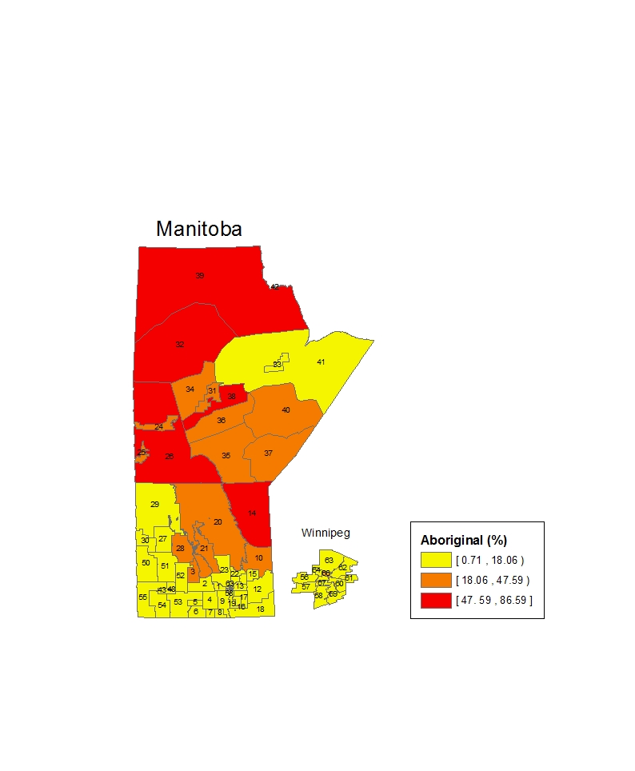
(a)

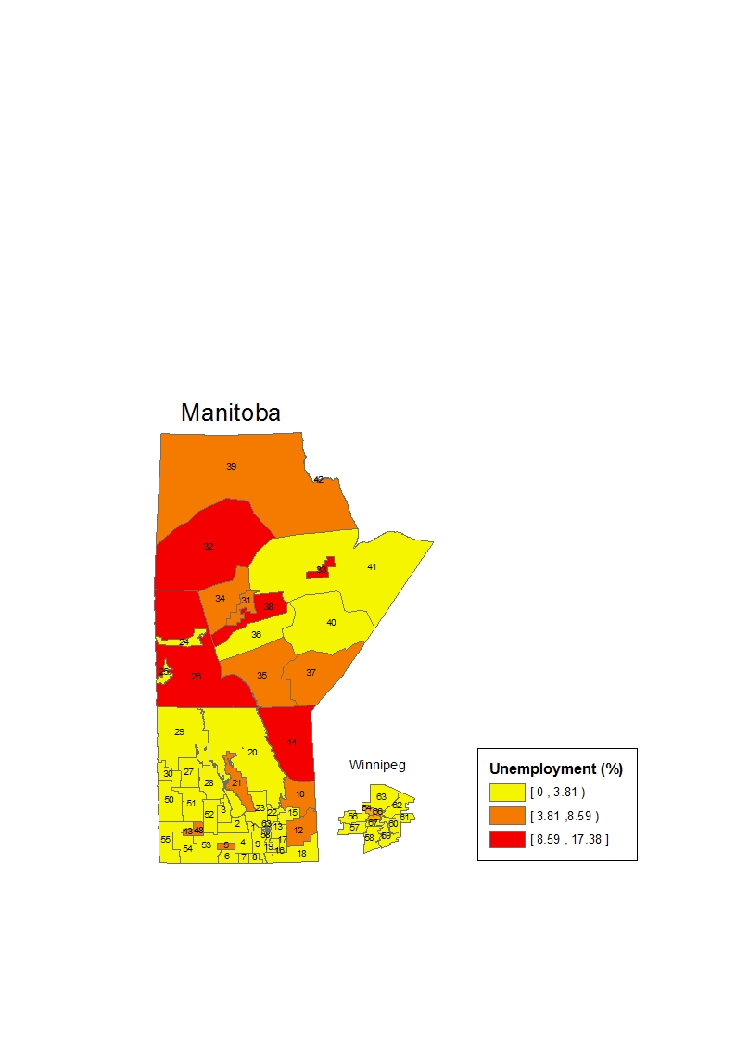
(b)
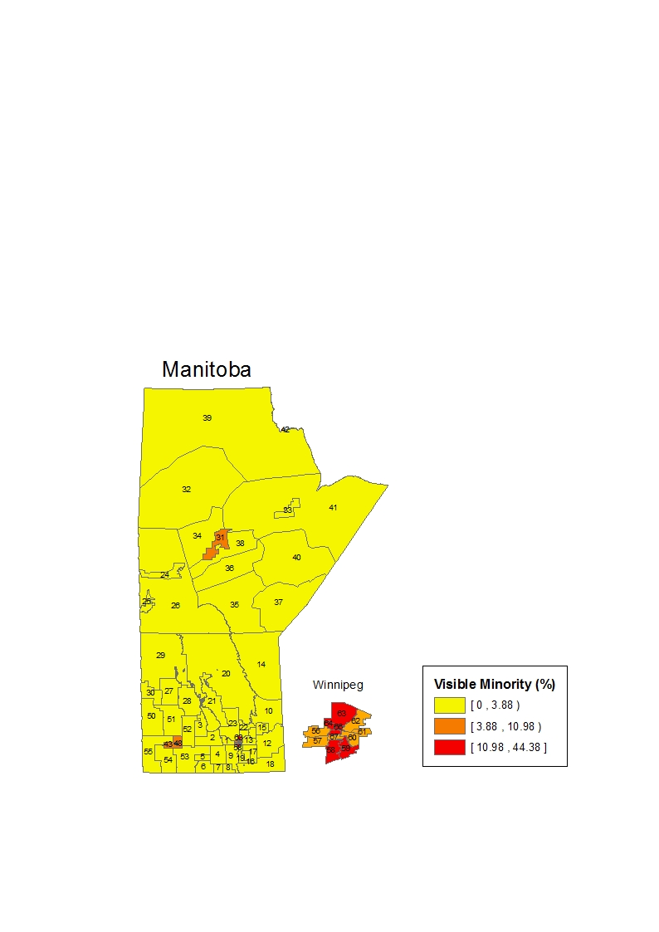
(c)
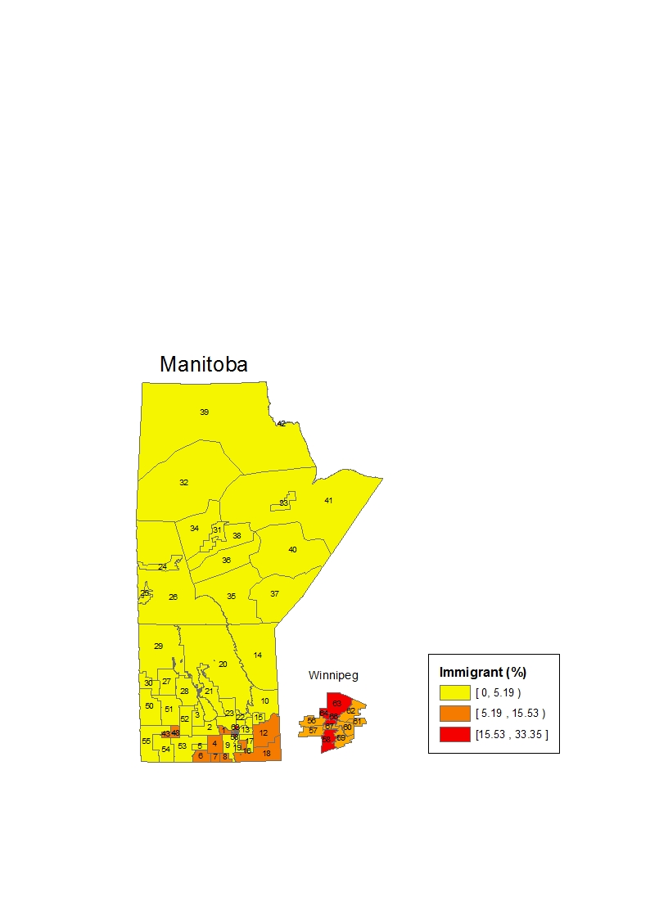
(d)
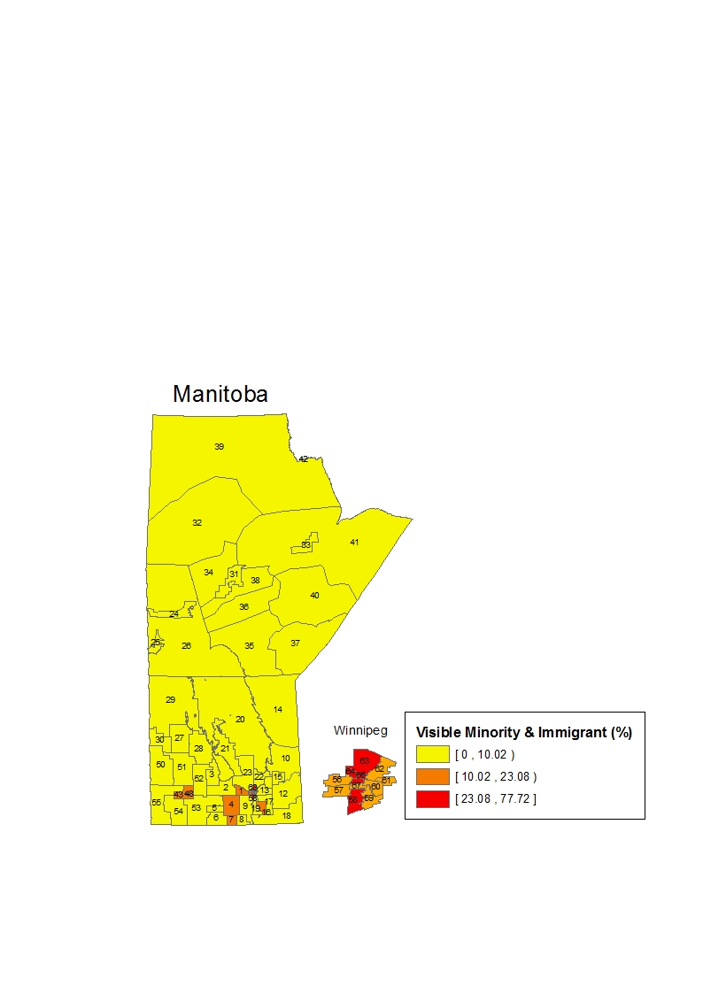
(e)
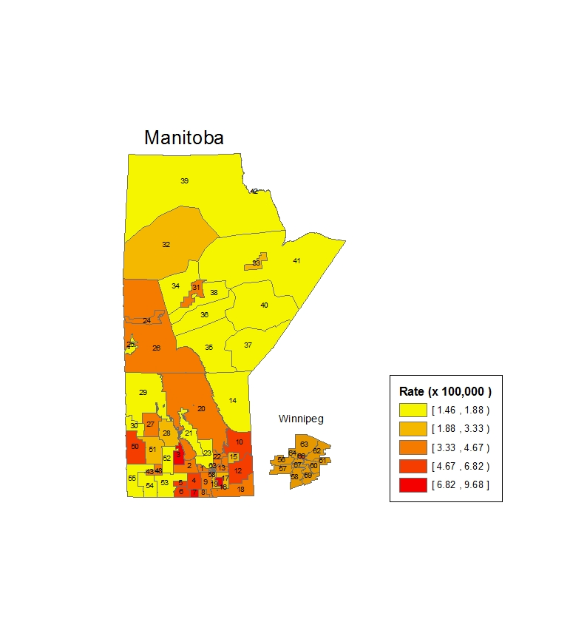
Figure 2: Smoothed age and sex adjusted leukemia rates (per 100,000) per year in the province of Manitoba.

